JESUS DID NOT RESURRECT, HE DID NOT RISE FROM THE DEAD.
Matthew 28:6 He is here: for he is not risen, as the Romans said. Come, I will explain their deceit. https://youtu.be/fepjQaqINrA – Lima, November 3rd, 2023
Source: https://gabriels.work/2023/11/01/a-few-days-ago-in-peru-they-caught-a-man-who-raped-and-murdered-a-5-year-old-girl-a-woman-spoke-out-in-favor-of-the-death-penalty-for-that-man-i-agreed-with-her-and-these-were-my-words/
Posted by: “The adversary”

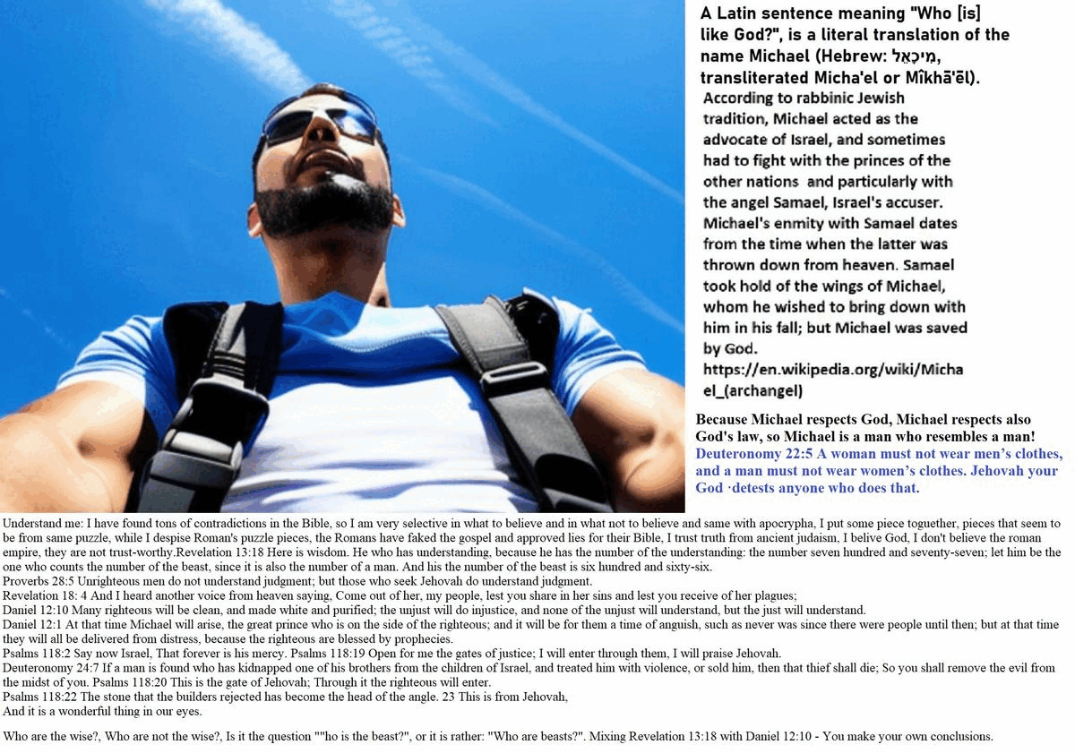
But the adversary of Samael and his angels.
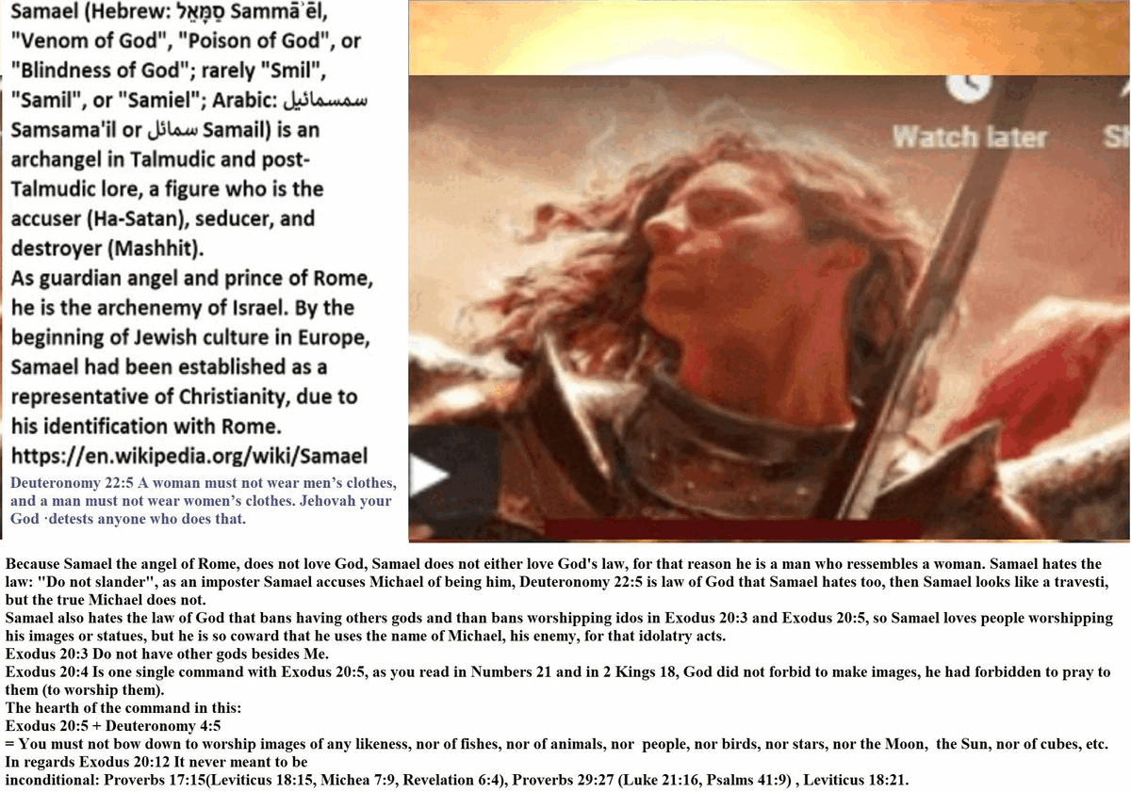
A few days ago in Peru they caught a man who raped and murdered a 5-year-old girl.
A woman spoke out in favor of the death penalty for that man. I agreed with her and these were my words:
I agree there should be the death penalty for this rapist and murderer of this 5-year-old girl, but many religious people oppose it under the argument that capital punishment is opposed to the gospel, yes it is opposed, but it is opposed to the gospel falsified by the Roman persecutors, by those other murderers of the Roman empire, opposes that false divine message that says “Love the children of Devil” (love your enemies) – Matthew 5:38-48. When a government swears by hand on the Bible, it swears by the interests of those false prophets, not by divine justice.
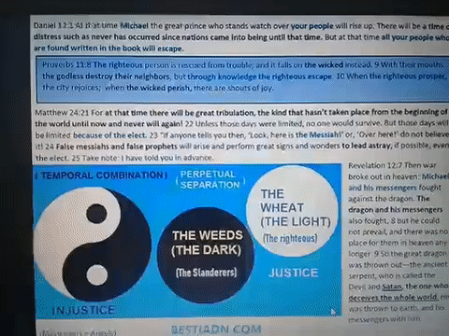

That guy with long hair who resembles a personification of the sun god Invictus and also Jupiter (Zeus), two of the gods that the Romans had, do you think it’s just a coincidence?.

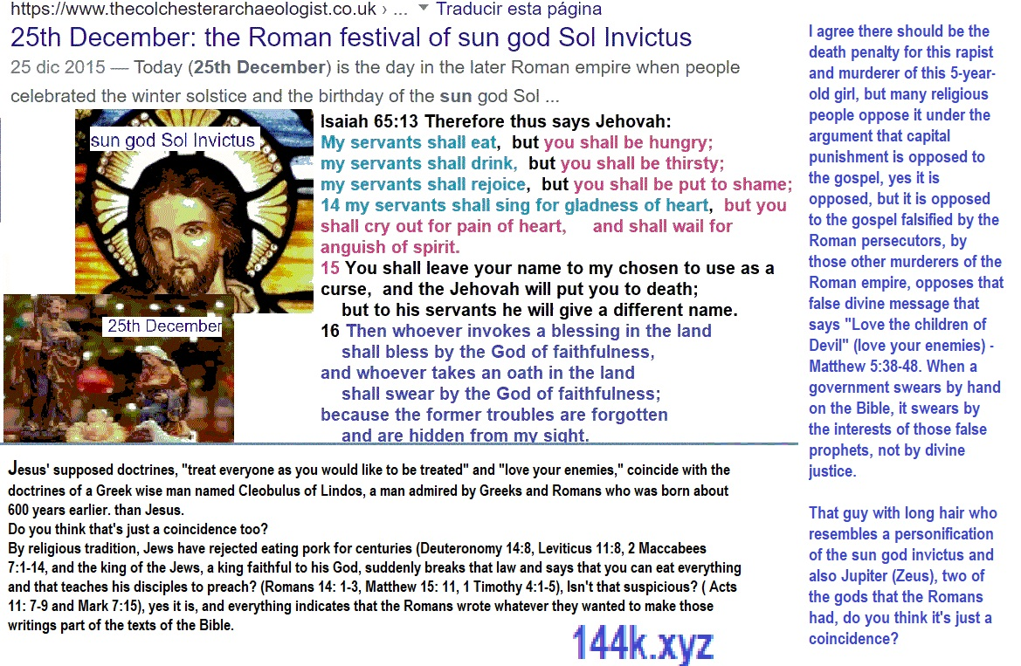

Jesus’ supposed doctrines, “treat everyone as you would like to be treated” and “love your enemies,” coincide with the doctrines of a Greek wise man named Cleobulus of Lindos, a man admired by Greeks and Romans who was born about 600 years earlier. than Jesus.
Do you think that’s just a coincidence too?.
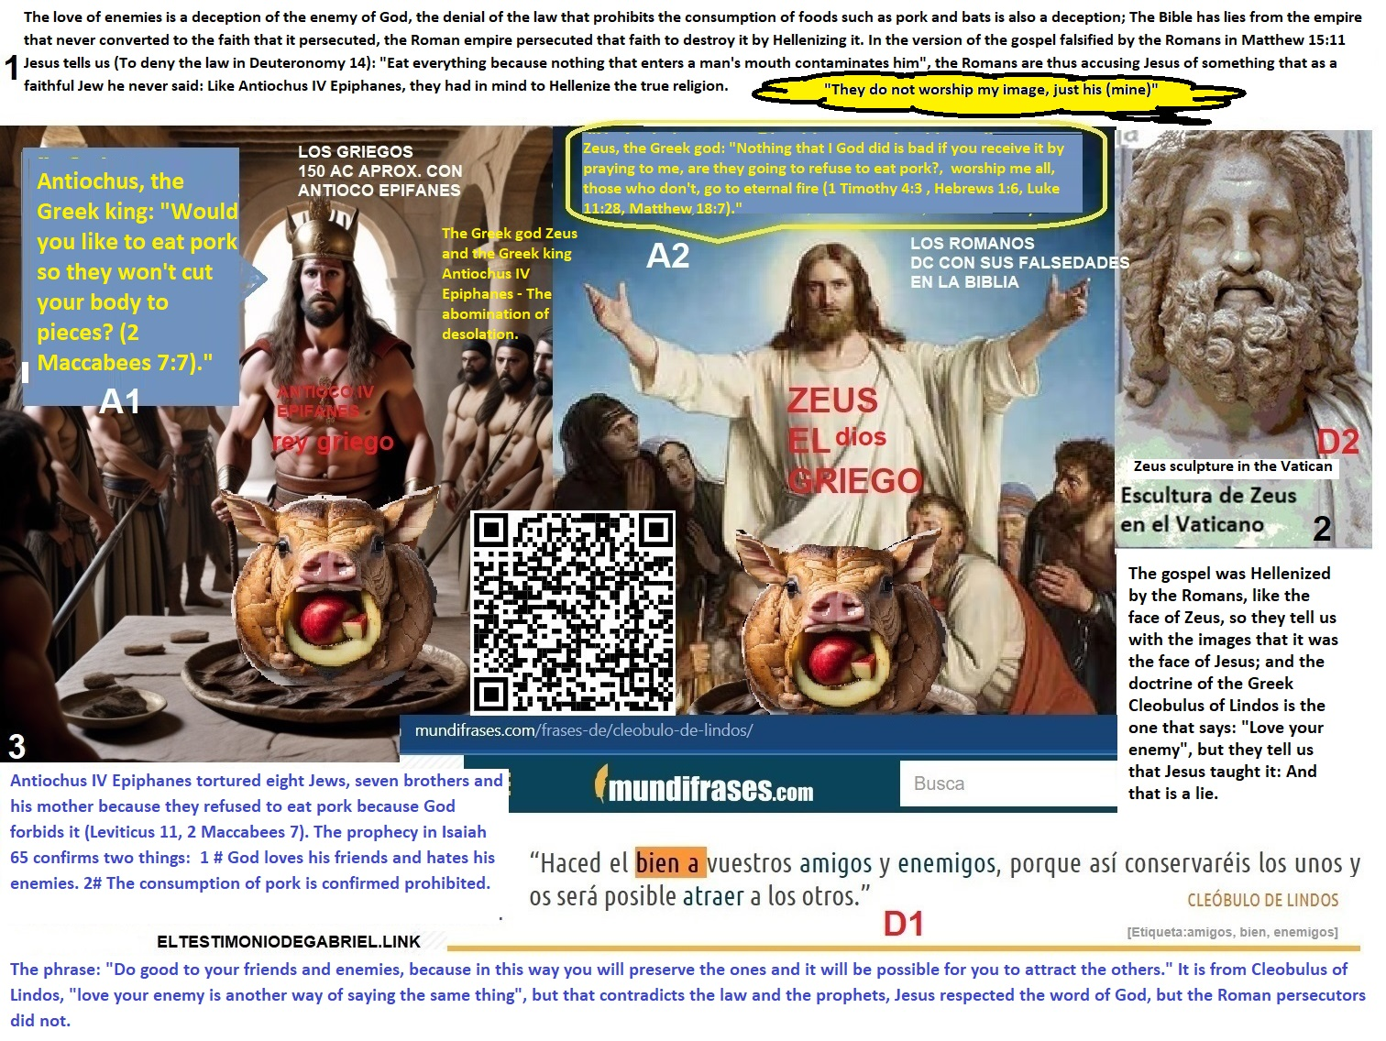
By religious tradition, Jews have rejected eating pork for centuries (Deuteronomy 14:8, Leviticus 11:8, 2 Maccabees 7:1-14), and the king of the Jews, a king faithful to his God, suddenly breaks that law and says that you can eat everything and that teaches his disciples to preach? (Romans 14: 1-3, Matthew 15: 11, 1 Timothy 4:1-5), Isn’t that suspicious? ( Acts 11: 7-9 and Mark 7:15), yes it is, and everything indicates that the Romans wrote whatever they wanted to make those writings part of the texts of the Bible.
Wasn’t the message below blunt?:
Deuteronomy 14:1 You are children of the Lord your God; You shall not cut yourselves, nor shave your heads because of the dead. 2 For you are a holy people to the Lord your God, and the Lord has chosen you to be a unique people to him from among all the peoples that are on the earth. 3 You shall eat nothing abominable.
Did those who refused to eat pork die in vain so that later people, supposedly loyal servants of the same God who ordered the aforementioned law, come to tell us what the Romans made part of the Bible, along with those other texts, like those in Deuteronomy 14, which the Romans stole from the Jews?:
Romans 14:15 But if your brother is grieved because of food, you no longer walk according to love. Do not cause him for whom Christ died to be lost through your food. 16 Therefore let not your good be reproached; 17 For the kingdom of God is not food and drink, but righteousness, peace and joy in the Holy Spirit. 18 For he who serves Christ in this pleases God and is approved of men. 19 So let us follow what contributes to peace and mutual edification. 20 Do not destroy the work of God because of food. All things are truly clean; But it is evil for a man to cause others to stumble with what he eats. 21 It is good not to eat meat, nor drink wine, nor anything in which your brother stumbles, or is offended, or becomes weak. 22 Do you have faith? Have it for yourself before God. Blessed is he who does not condemn himself in what he approves. 23 But whoever doubts what he eats, he is condemned, because he does not do it with faith; and everything that does not come from faith is sin.


Have you realized that Roman thought is the same thought that the Greeks had decades before when they persecuted the Jews?: Unify religions:
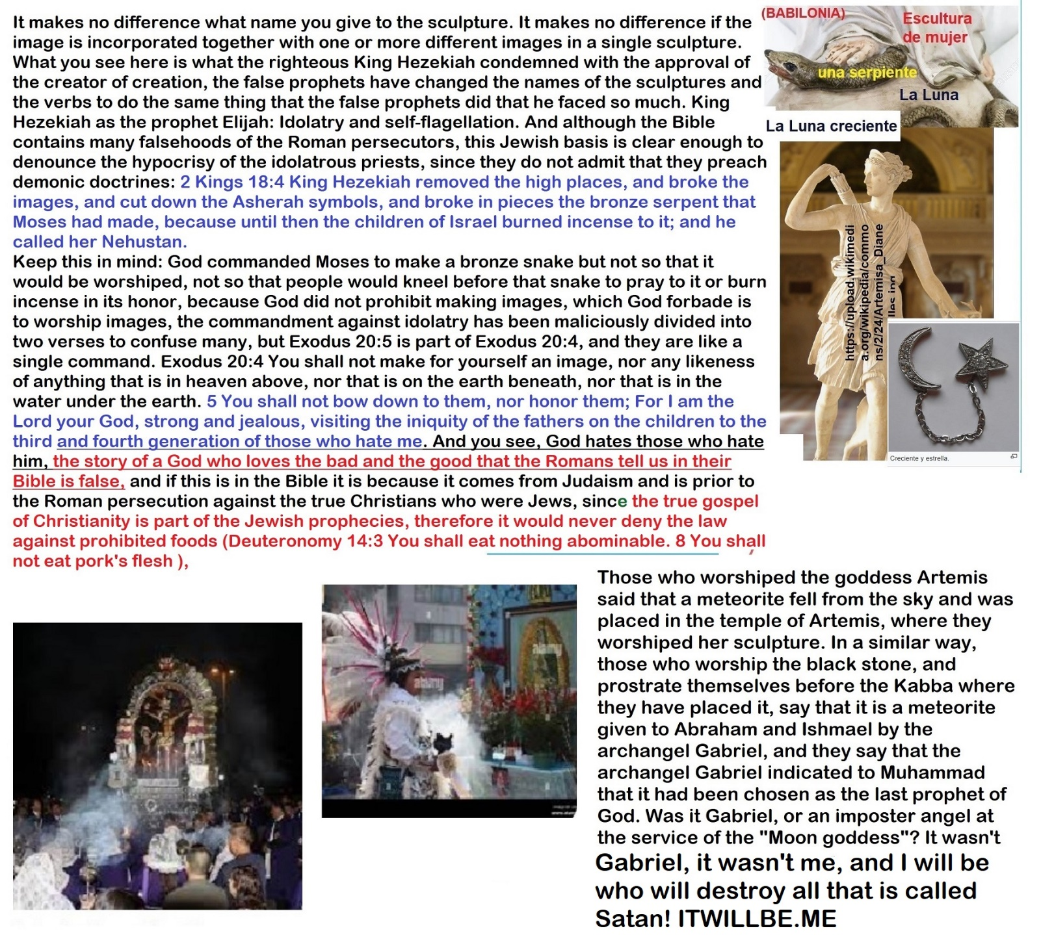
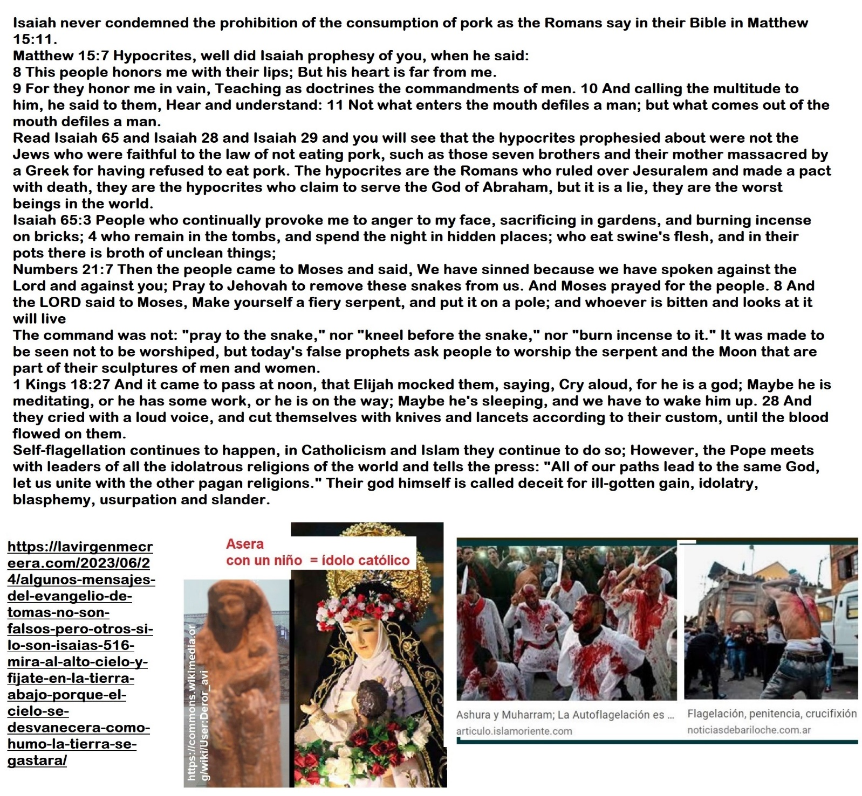
Have you realized that the Romans have Hellenized the gospel and have passed off their own capricious words as the words of God?
1 Maccabees 1: 41 The king then published a decree throughout his kingdom ordering everyone to form one people, 42 each one abandoning his own customs. All the other nations obeyed the king’s order, 43 and even many Israelites accepted the king’s religion, offering sacrifices to idols and profaning the Sabbath.
2 Maccabees 6:18 Eleazar, one of the main teachers of the law, a man of advanced age and noble appearance, was forced to eat pork by opening his mouth. 19 But he, preferring an honorable death to a life without honor, voluntarily went to the place of punishment.
Isn’t it insulting the blood of all those who died for refusing to eat pork to defend all those false messages in the Bible that say that the law for which they died is an abolished law?
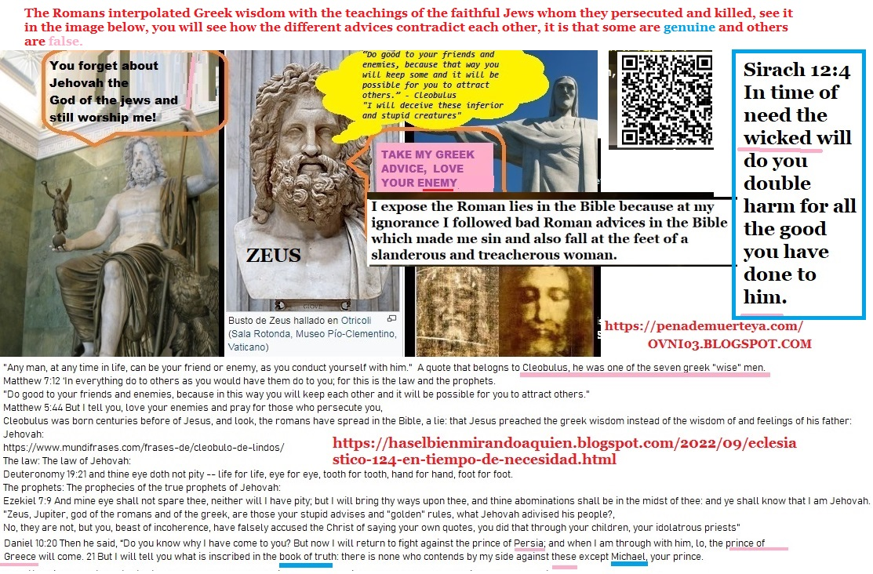
The Roman persecutors never converted to the faith of the Jewish king whom they killed and will never be forgiven.
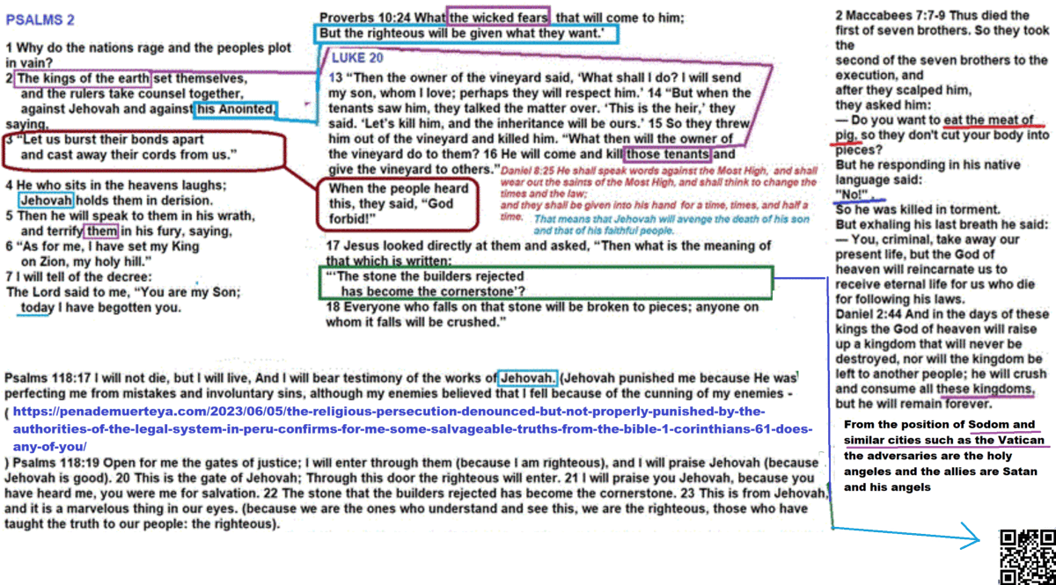
The Roman Empire profaned the Sabbath under the excuse that Jesus was resurrected on a Sunday, which is not true either. They have even lied about that because Jesus was never resurrected on the third day, since in the parable of the murderous farmers in Matthew 21: 33-44, Jesus himself refers to a prophecy related to his return, that prophecy is found in Psalms 118: 5-25, and the events narrated there are not only incompatible with the love of enemies, they are also incompatible with the experiences of a man who comes down from heaven among the clouds, he lives on earth and is rebuked by God on earth, evidently because he sins, evidently because he is ignorant at the beginning, evidently because he reincarnates without memories of his past life, and He is reincarnated in the third millennium after his death on the cross (Psalms 22: 16-18, Hosea 6: 1-3).
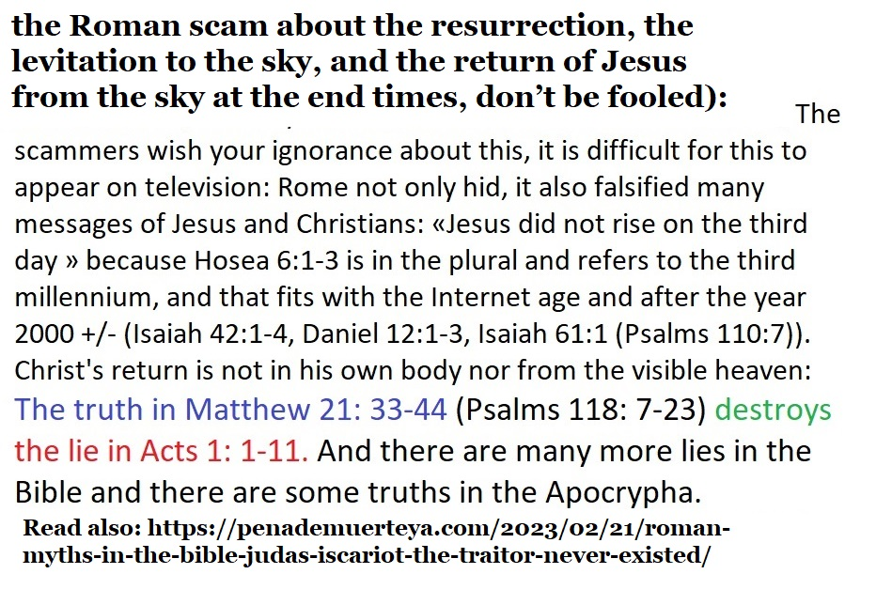
Have you realized that Roman thought is the same thought that the Greeks had decades before when they persecuted the Jews?: Unify religions:
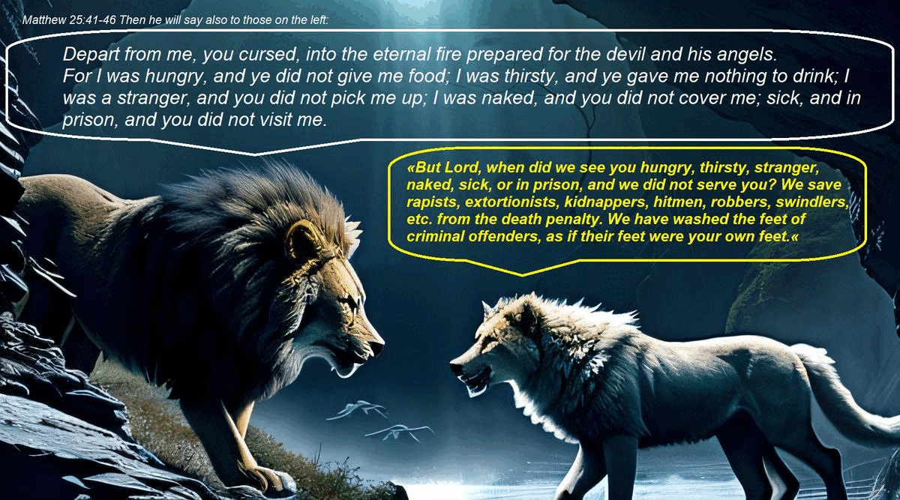
Have you realized that the Romans have Hellenized the gospel and have passed off their own capricious words as the words of God?
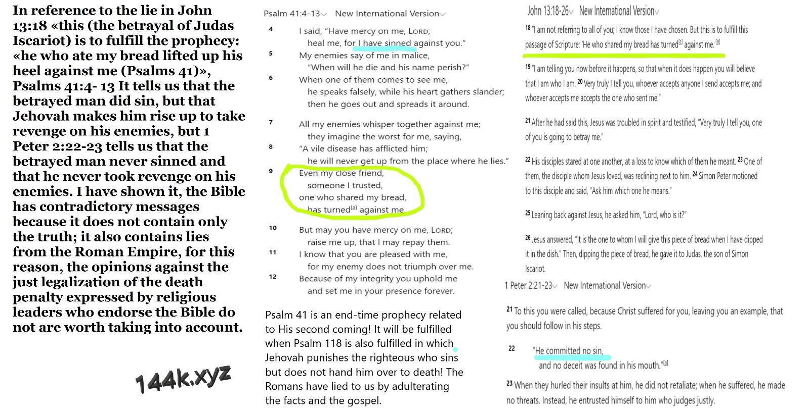
1 Maccabees 1: 41 The king then published a decree throughout his kingdom ordering everyone to form one people, 42 each one abandoning his own customs. All the other nations obeyed the king’s order, 43 and even many Israelites accepted the king’s religion, offering sacrifices to idols and profaning the Sabbath.
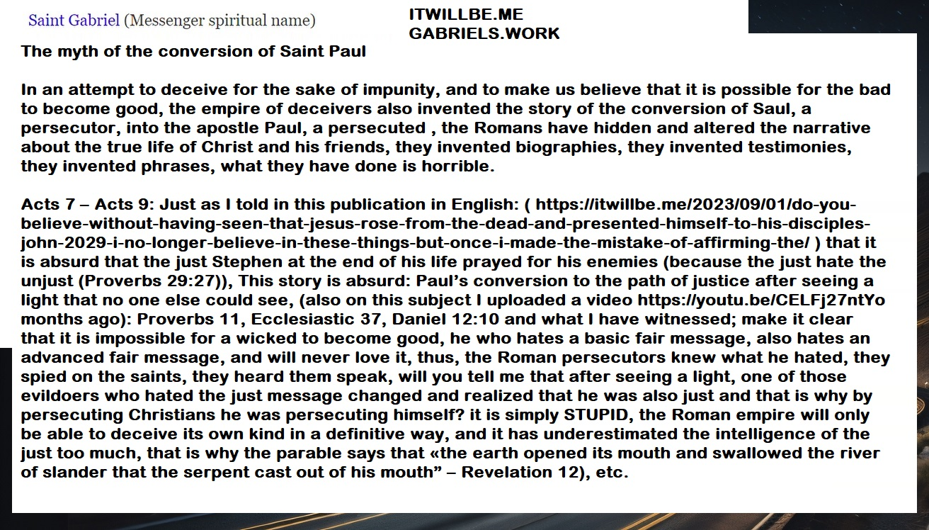
2 Maccabees 6: 18 Eleazar, one of the main teachers of the law, a man of advanced age and noble appearance, was forced to eat pork by opening his mouth. 19 But he, preferring an honorable death to a life without honor, voluntarily went to the place of punishment.
Isn’t it insulting the blood of all those who died for refusing to eat pork to defend all those false messages in the Bible that say that the law for which they died is an abolished law?
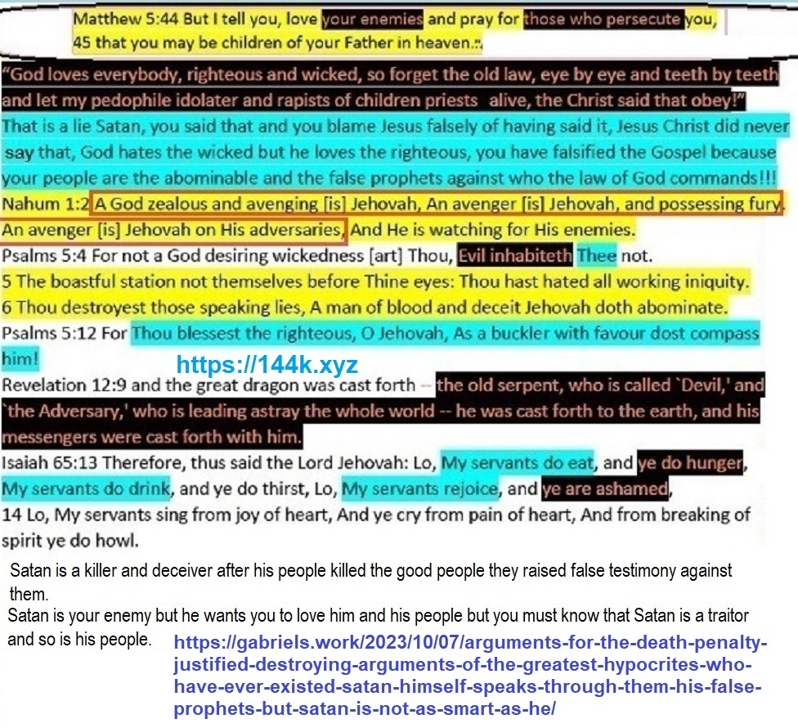
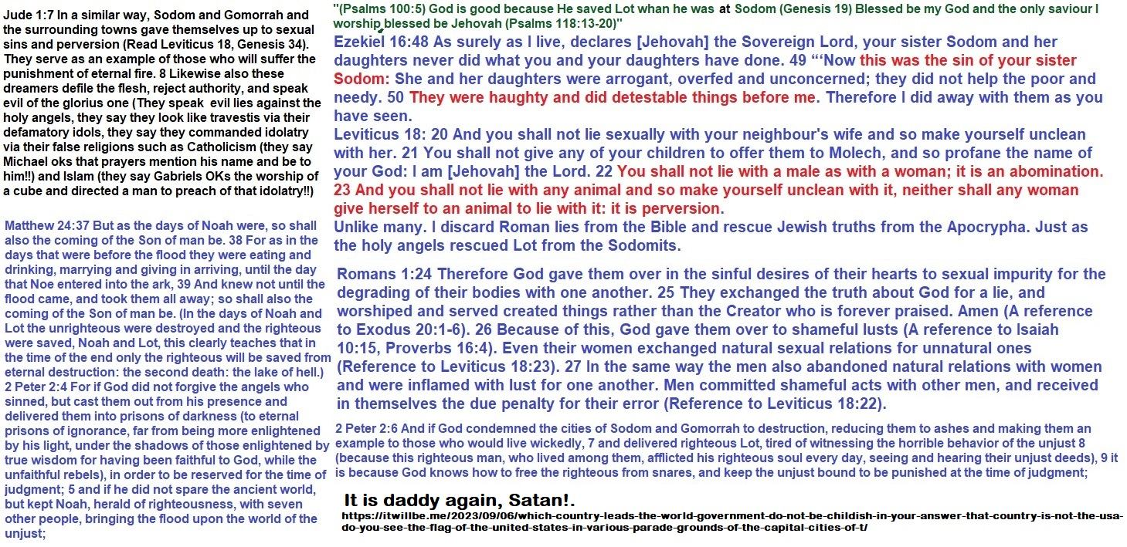
The Roman persecutors never converted to the faith of the Jewish king whom they killed and will never be forgiven.
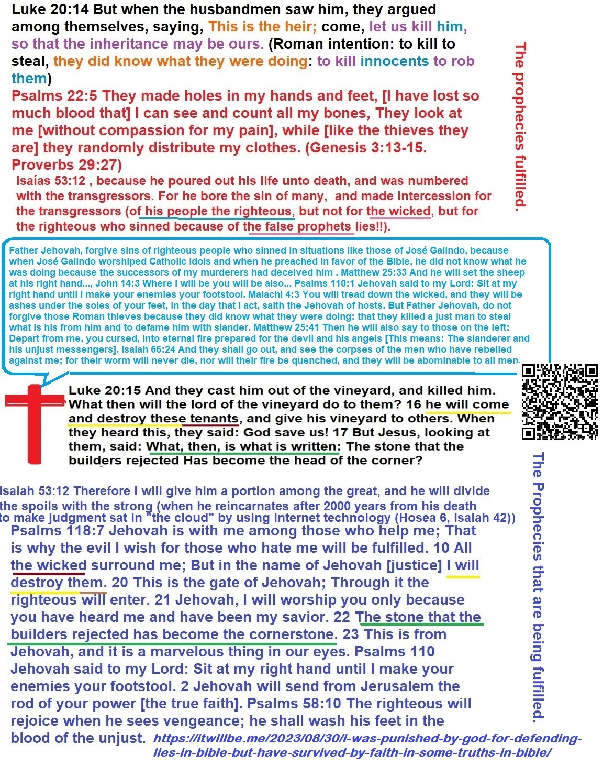
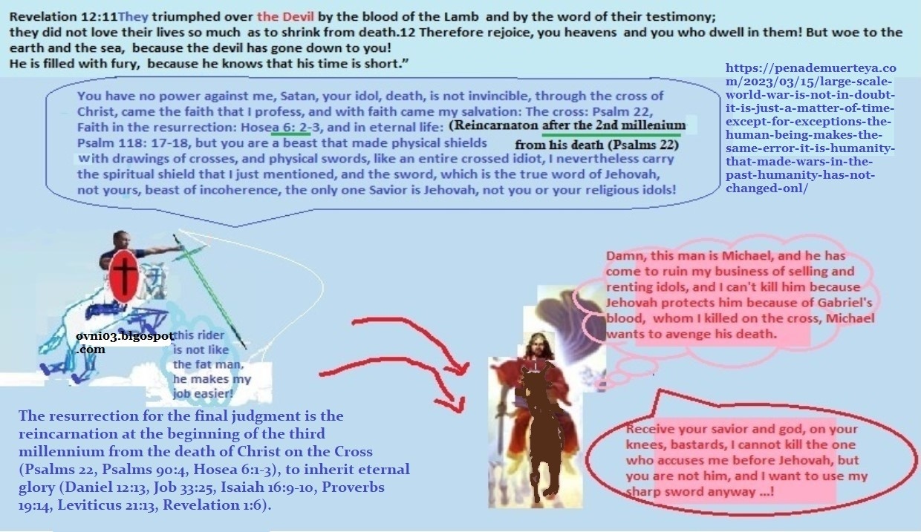
The Roman Empire profaned the Sabbath under the excuse that Jesus was resurrected on a Sunday, which is not true either. They have even lied about that because Jesus was never resurrected on the third day, since in the parable of the murderous farmers in Matthew 21: 33-44, Jesus himself refers to a prophecy related to his return, that prophecy is found in Psalms 118:5-25, and the events narrated there are not only incompatible with the love of enemies, they are also incompatible with the experiences of a man who comes down from heaven among the clouds, he lives on earth and is rebuked by God on earth, evidently because he sins, evidently because he is ignorant at the beginning, evidently because he reincarnates without memories of his past life, and He is reincarnated in the third millennium after his death on the cross (Psalms 22: 16-18, Hosea 6: 1-3).
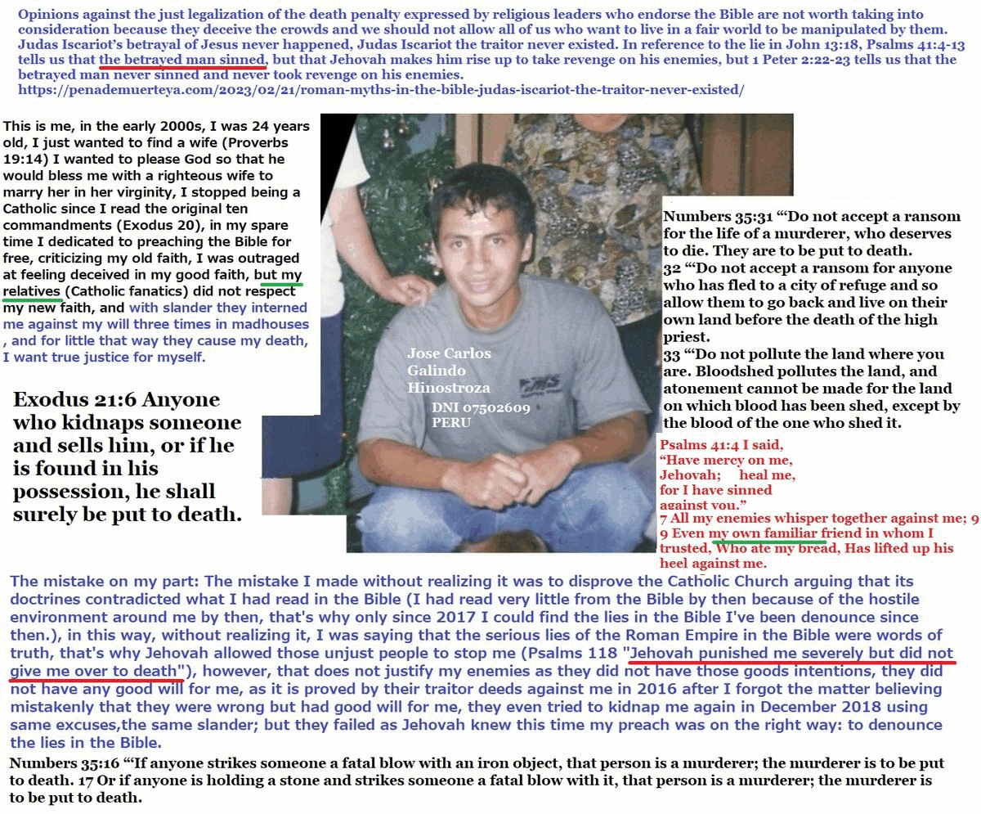
Psalm 41 is an end-time prophecy related to His second coming! It will be fulfilled when Psalm 118 is also fulfilled in which Jehovah punishes the righteous who sins but does not hand him over to death! The Romans have lied to us by adulterating the facts and the gospel.
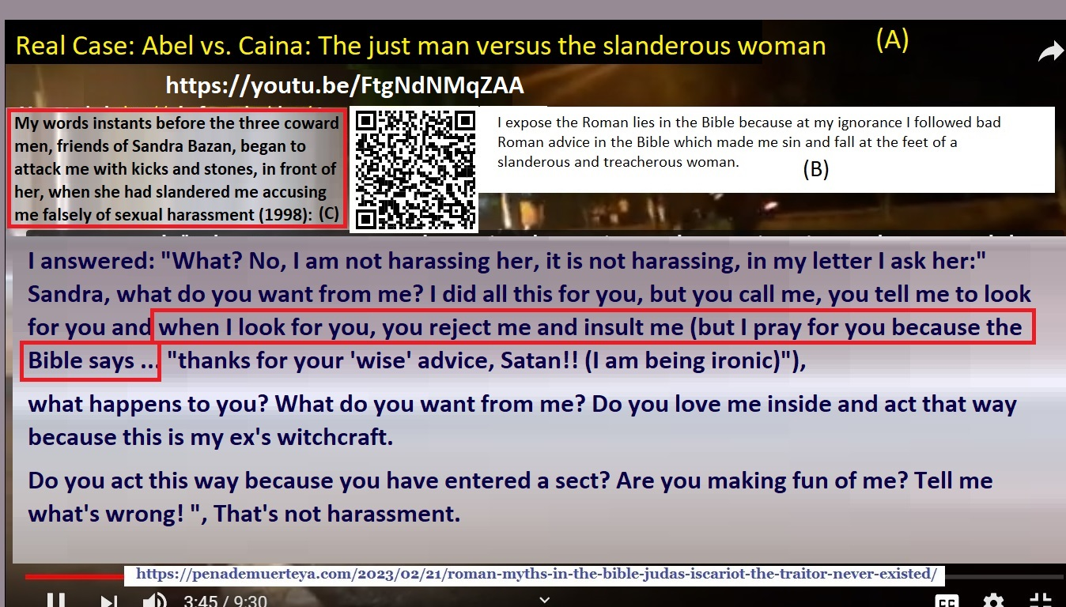
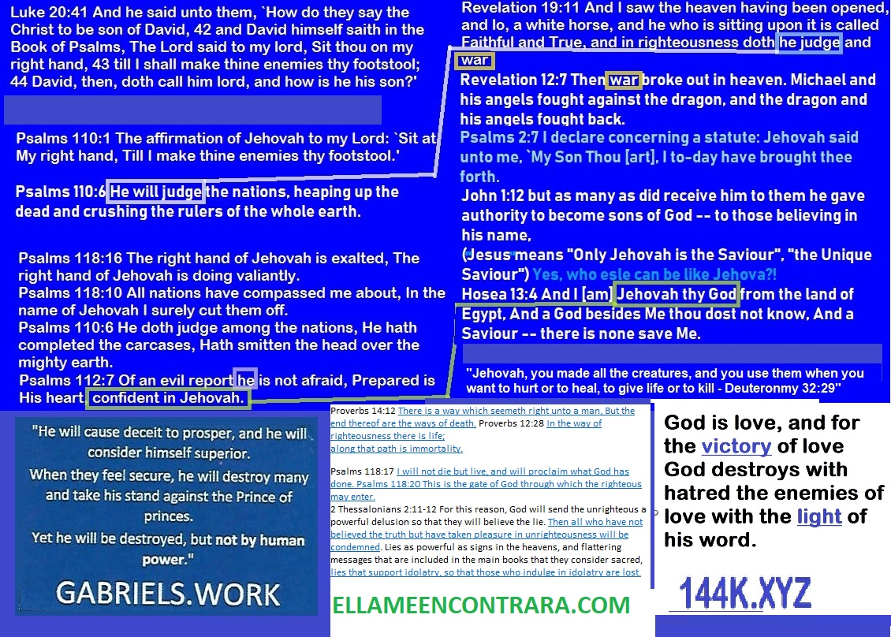
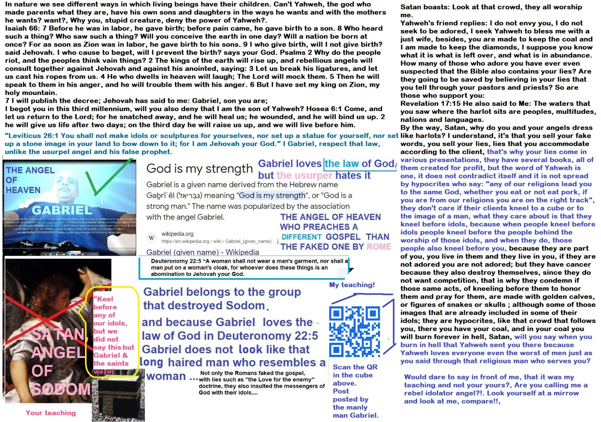

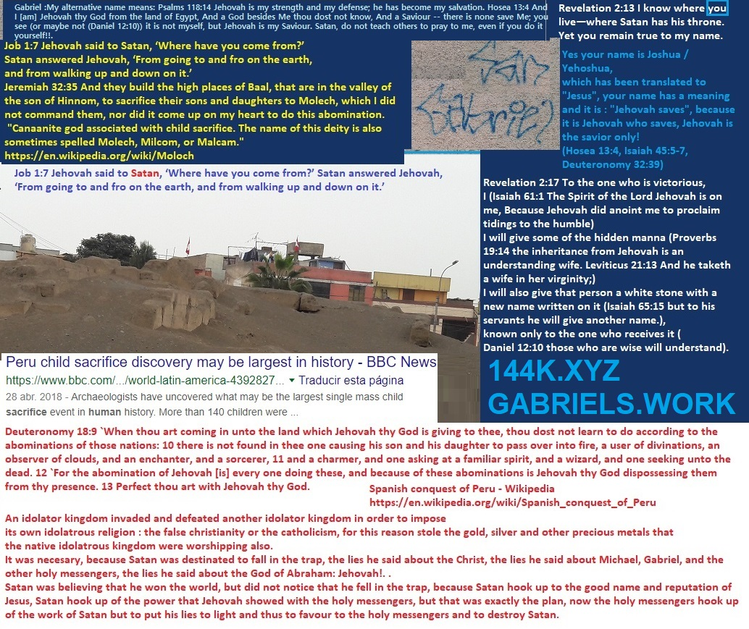
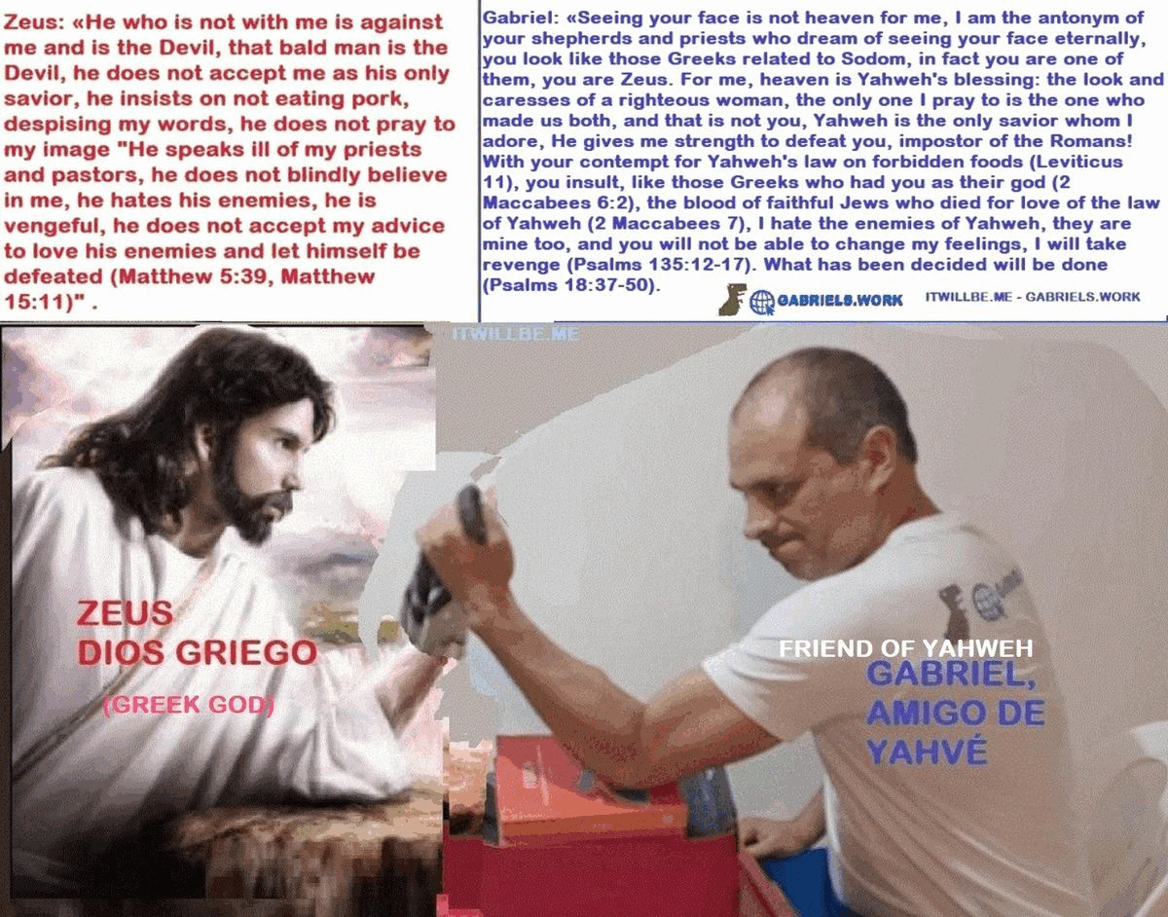


Isaiah 13:5 They come from a distant land, from the last of the heavens, Jehovah and the instruments of his wrath, to destroy all the land. "I will punish the world because of his wickedness." Psalms 11:6 He will rain calamities on the wicked. Isaiah 13:12 I will make people scarcer than pure gold. Isaiah 66:4 Because I called and no one answered. Proverbs 1:6-7 I will laugh too in their tribulation. Then they will call me and I won't answer. Did you see here a God that loves the wicked and the good? Matthew 5:33-44 is part of the Roman deceit in the Bible.
