144K.XYY – Is the Roman Empire trust-worthy?, Do you really believe Jesus died for love for the wicked?, Do you really believe that the wicked romans who killed Jesus haven’t deceived the world with the Bible?. Do you really believe in the narration of the facts about a genocide narrated by the genocidaires?.
José Galindo ( https://eltrabajodegabriel.files.wordpress.com/2023/08/the-holy-pact.docx - https://gabriels52.files.wordpress.com/2023/08/si-en-verdad-eres-hijo-de-dios-di-a-estas-piedras-que-se-conviertan-en-pan-version-extendida.docx) it will be me, Seré yo 10 de September de 2023 21 Minutes
Did Jesus die for love of the lost sheep or for love of the wolves? Although the wolf disguises itself as a sheep, it will never be a sheep, but the lost sheep can return to the right path. Does it seem logical to you that the good shepherd loves the sheep? and also love the wolves? Does it seem logical to you that the good shepherd has preached to the sheep that they love their enemies, the wolves, and that they allow themselves to be eaten by the wolves, offering both cheeks? Remember that Jesus was a righteous man.
Is the Roman Empire trust-worthy?, Do you really believe Jesus died for love for the wicked?, Do you really believe that the wicked romans who killed Jesus haven’t deceived the world with the Bible?. Do you really believe in the narration of the facts about a genocide narrated by the genocidaires?.
Book of Enoch Chapter 47:1 In those days the prayer (words) of the righteous and the blood of the righteous will have ascended from the earth to the Lord of spirits. 2 In such days the saints who dwell on high in heaven will be united in one voice: they will supplicate, pray, praise, give thanks and bless the name of the Lord of spirits, in the name of the blood of the righteous who has been poured out and so that the prayer of the righteous is not in vain before the Lord of spirits, justice is done and their patience is not eternal. 3 In those times I saw the Head of Days when he sat on the throne of his glory and the books of the living were opened before him. All his hosts that dwell on high in heaven and his court were before him. 4 And the The hearts of the saints were filled with joy, because the number of the righteous has been established, the prayer of the righteous has been heard and the blood of the righteous has been denounced before the Lord of spirits. The so-called apocryphal texts have some truths, after reading the above, you already know that the blood of Christ, the righteous, was never for love of the wicked, only for love of the righteous, just like all the righteous blood shed. A stray sheep and a wolf are not the same, the stray sheep needs information so as not to sin, the wolf only needs to be destroyed because it can never be a sheep, that is why the shepherd uses weapons, although the wolf is stronger than the shepherd, The wolf does not have the weapons that the shepherd creates with his intelligence.
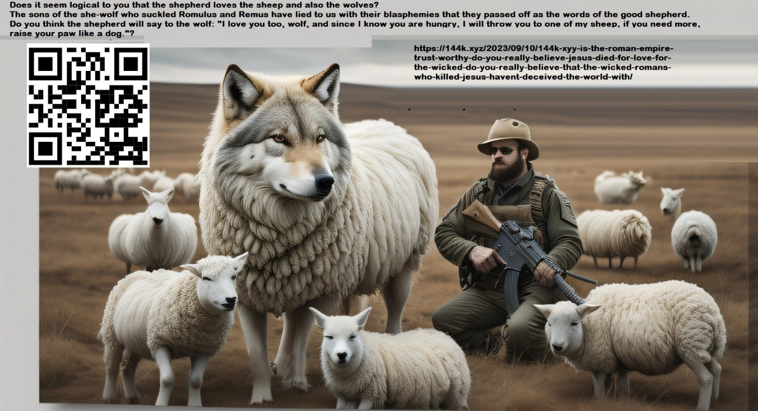
Do you see anything compatible with the doctrine of love for the enemy in this passage from Peter that alludes to false prophets, such as those monsters, who, using the name of God as an excuse, approach little boys and little girls with perverse instincts to rape them sexually? 2 Peter 2:12 Such individuals are like brainless beasts, destined by their nature to be caught in the stocks and die. They revile what they do not know, and they will die with the death of beasts.
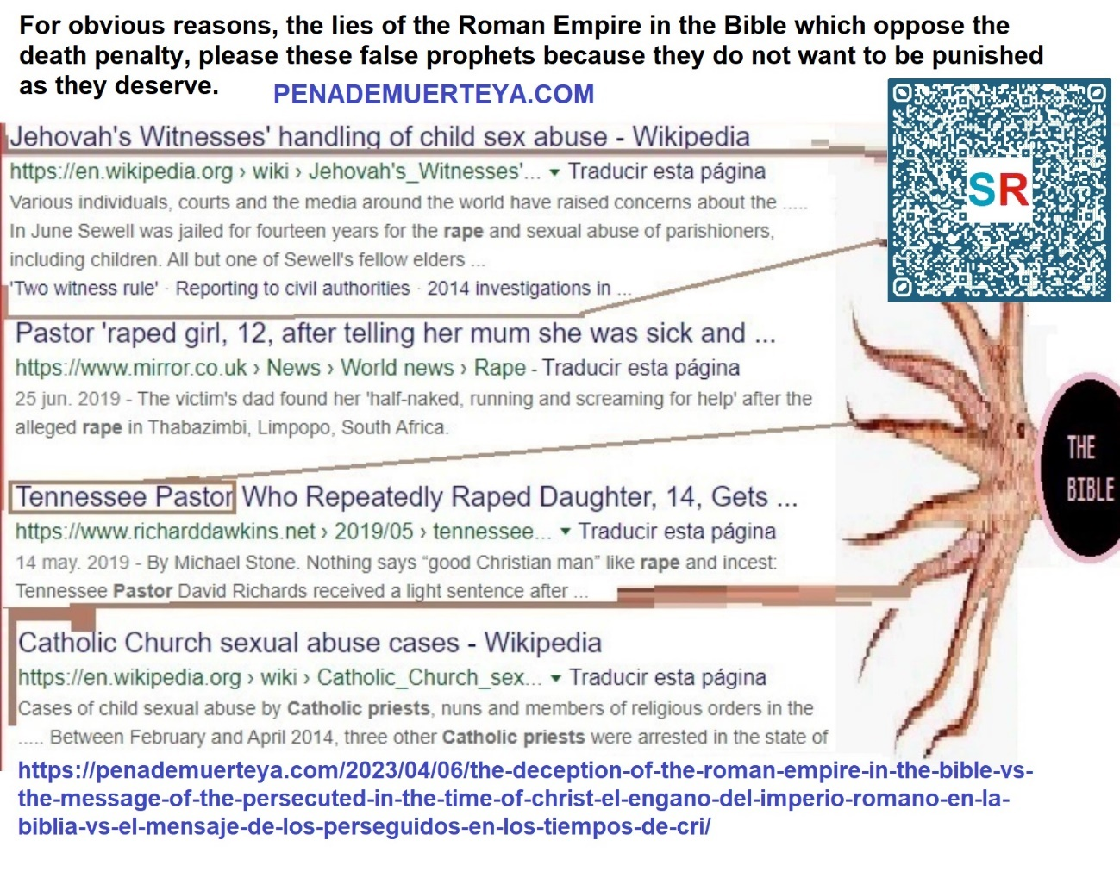
Daniel 12:10 The righteous will be put on track, cleansed (forgiven of their sins), and made white and purified (enlightened with the knowledge of the truth, they will leave unclean foods and thus be purified); but the unjust will continue to be unjust, and none of the unjust will understand the message of coherence, but those who understand will understand it. This is so easy to understand for me, and I know that it will be for others too, that’s why one of the domains of my blog refers to all the people capable of understanding me: the 144000 “https://144k.xyz&#8221;..
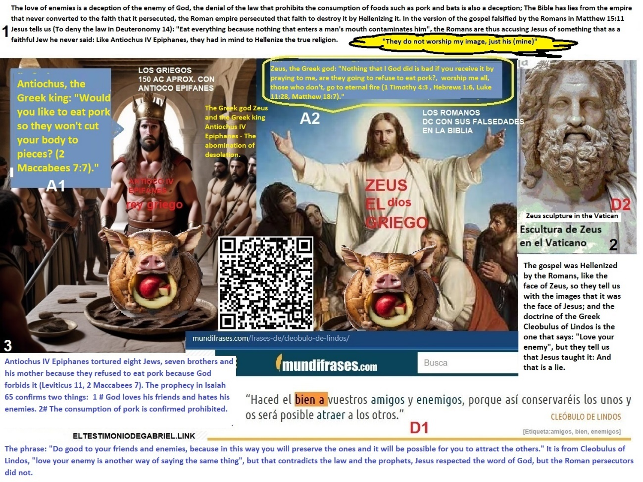
I make it clear that I do not defend everything in the Bible, the Romans have falsified the words of the Jews whom they persecuted, although not all the words… Revelation 7:4 And I heard the number of those who were sealed: one hundred and forty-four thousand sealed of all the tribes of the children of Israel. Revelation 14:1 Then I looked, and, behold, the Lamb was standing on Mount Zion, and with him one hundred and forty-four thousand, having his name and his Father’s name written on their foreheads. Revelation 14:9 And the third angel followed them, saying with a loud voice, If anyone worships the beast and his image, and receives its mark on his forehead or on his hand, 10 he also will drink of the wine of the wrath of God, that has been poured pure into the cup of his wrath; and he will be tormented with fire and brimstone before the holy angels and the Lamb; 11 and the smoke of his torment ascends forever and ever. And those who worship the beast and his image have no rest day or night, nor anyone who receives the mark of his name.
I reiterate the clarification, not because I quote passages from the Bible, that means that it has my full support, of the Bible I only support the part that belongs to Judaism, the dragon is the author of absurd teachings that it does not follow either: “the love of the enemy”, but the dragon, being a slanderer, attributed that teaching to the king of Israel, whom he murdered on a cross for having refused to worship the beast, his idol and to follow Hellenic customs prohibited for Jews such as eating pork meat.
Revelation 12:1 A great sign appeared in heaven: a woman clothed with the sun, with the moon under her feet, and on her head a crown of twelve stars. 3 Another sign also appeared in heaven: behold, a great scarlet dragon, having seven heads and ten horns, and on its heads seven diadems;
If the prince loved the princess’s enemy, how then would he fight for her?.
As some of the signs in Spanish that I put up in various streets of “Babylon, Sodom and Egypt” where no one supports me say: “God is love, and for the victory of love, God destroys with hatred the enemies of love with the light of her word. “, and this is how I fight for her, for Luz Victoria, my future wife who I still don’t know, do I do it by loving the dragon? No, because I don’t intend to feed the dragon with her!
I do this hating the dragon, I do this hating the enemy.


The prince who is the princess’s boyfriend hates the Dragon, he hates his enemies, he loves the princess and he loves the princess’s faithful people, tell me if any of those pagans who despise us have ever written things like the things that I write, then don’t say “we are all equal.”
Each of our men seeks his own faithful wife, taken in her virginity, because those who are ours are faithful. Leviticus 21:13 He will take a virgin woman as his wife. 14 He will not take a widow, nor a divorced woman, nor a prostitute, nor a harlot, but he will take a virgin from her people as a wife, 15 so that she may not profane her offspring among her people; for I, the Lord, am he who sanctifies them.
Unbelievers are something else. The infidels are unfaithful even with their images and gods, they worship many images and pray to many gods. While eating pork they say that our God Yahweh is with them, hahaha.
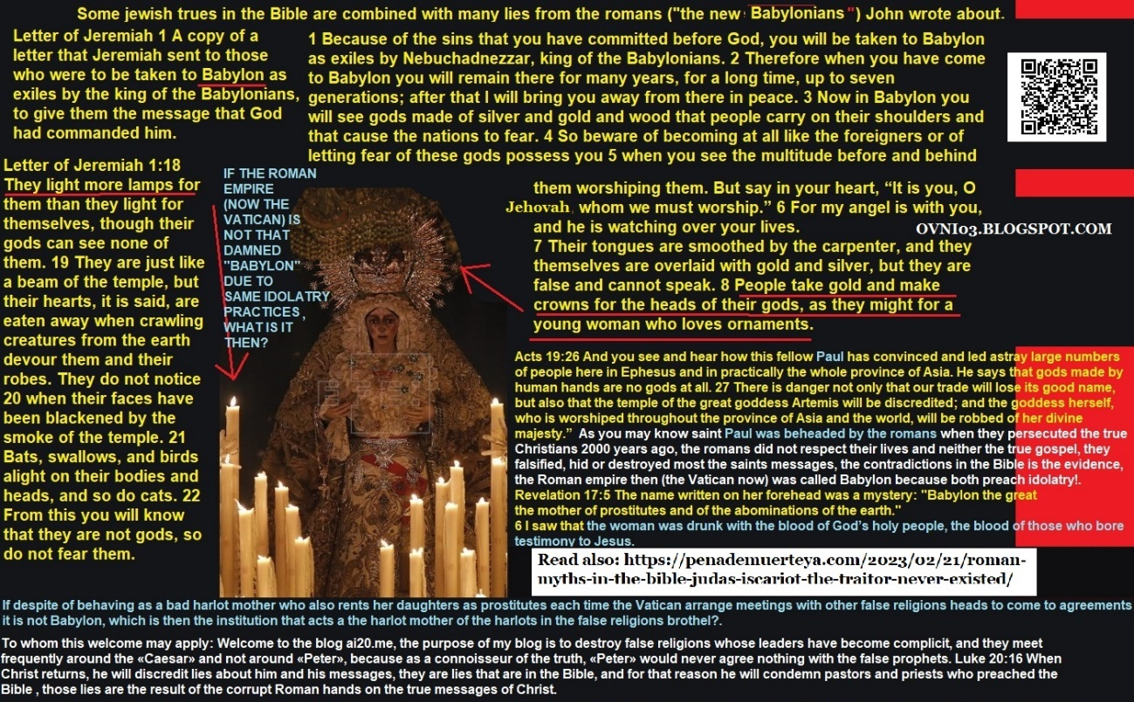
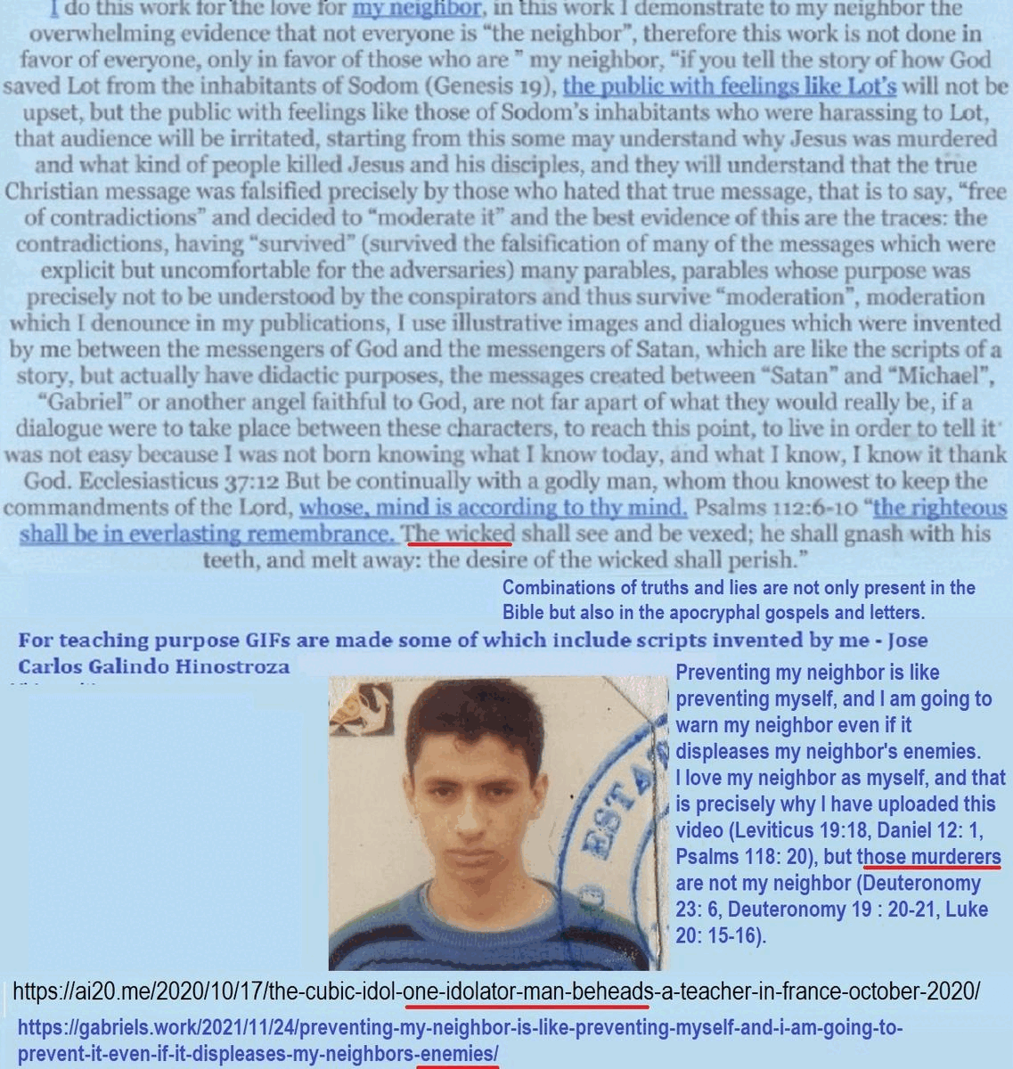

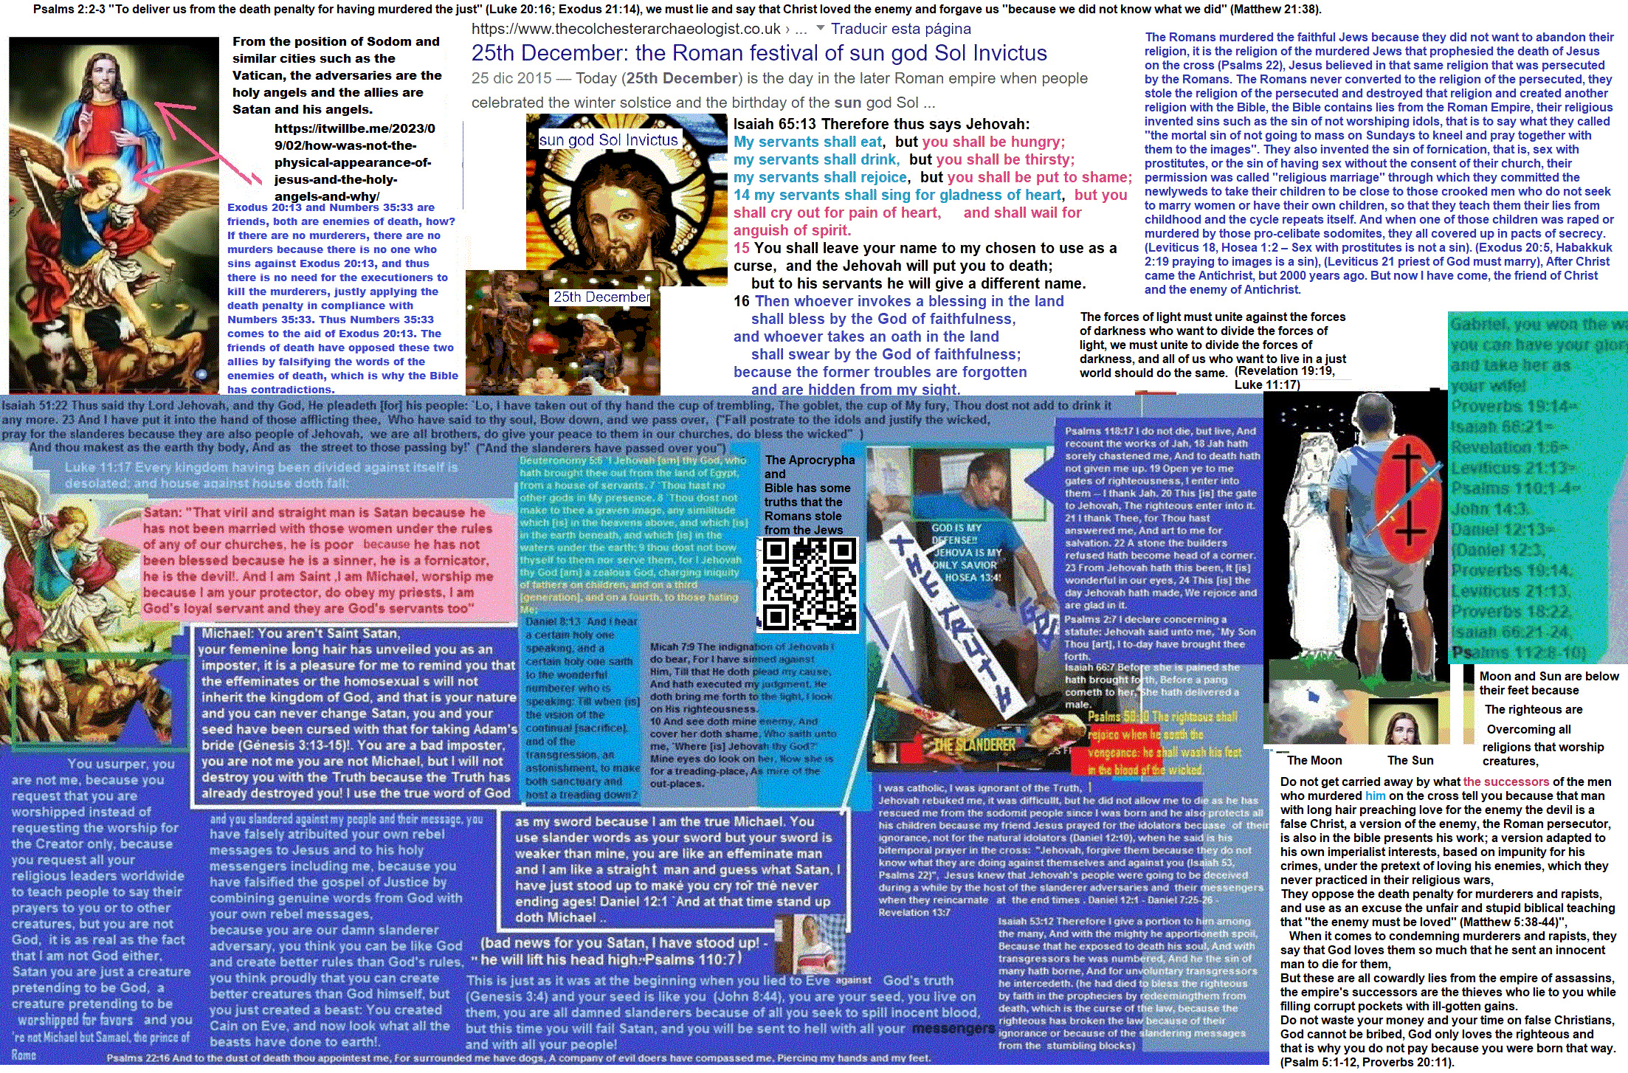
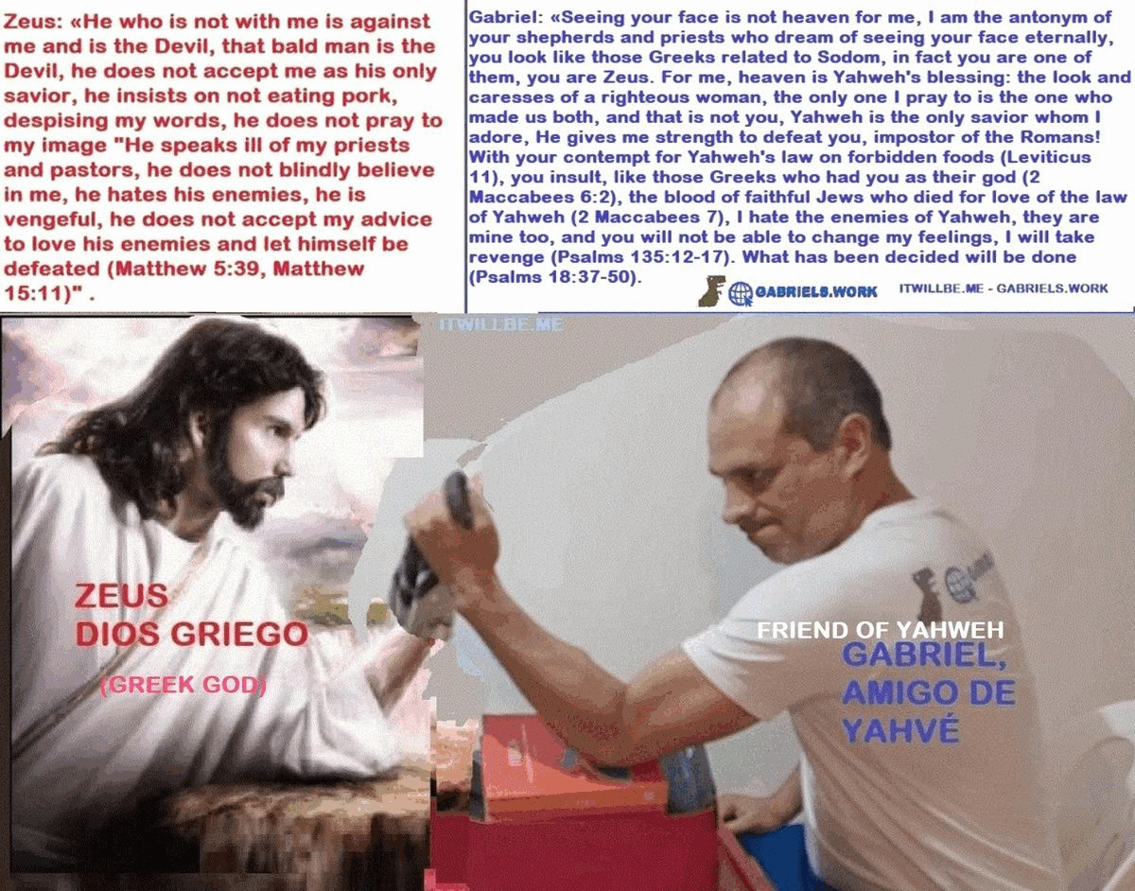

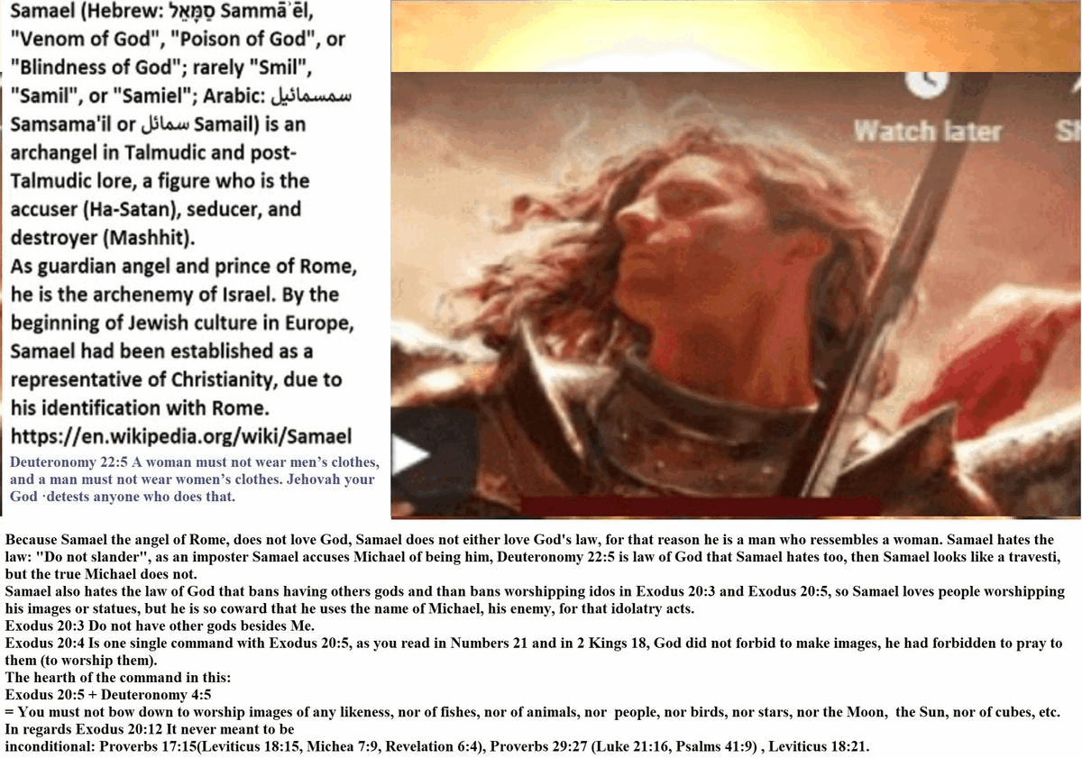
2 Maccabees 7:7 After the first brother had died in this way, they brought forward the second for their sport. They tore off the skin of his head with the hair, and asked him, ‘Will you eat pork rather than have your body punished limb by limb?’ 8 He replied in the language of his ancestors and said to them, ‘No.’ Therefore he in turn underwent tortures as the first brother had done. 9 And when he was at his last breath, he said, ‘You accursed wretch, you dismiss us from this present life, but the King of the universe will raise us up to an everlasting renewal of life, because we have died for his laws.’ (Deuteronomy 14:3 You shall not eat any abhorrent thing. Deuteronomy 14:8 You shall not eat pork.)
Can you imagine the seven brothers and their mother in reincarnation saying this: “In our past life we died for refusing to eat pork because we loved the law of Yahweh our God, in our final minutes alive we cursed King Antiochus IV Epiphanes for having ordered our tortures and deaths; but in this new life we have accepted Jesus as our only savior and following his advice we love and bless our enemy Antiochus IV Epifames, and we eat pork without worrying, because Jesus has said that what enters the mouth of man no longer contaminates man, furthermore, and that we must love our enemies, all the evils of Antiochus IV Epiphanes have been forgiven because he accepted Jesus as his only god and savior, and it is so how we are sitting at the same table eating pork, and we would have wished that Jesus would come in our days to tell us this to eat pork while accepting the gifts of Antiochus and thus avoid the death we had”?. I do not conceive that possible, that is absurd. Did Jesus lie or did the seven brothers lie? No! Those who lied against the blood of the righteous were the Romans. They attributed the authorship of Hellenic doctrines to Jesus and the other righteous Jews that they they massacred in their genocide.

Can you also imagine that those seven brothers and their mother celebrating Christmas in their reincarnation every December 25th or resting on Sundays and not Saturdays?
The Romans worshiped and still worship the Sun, through their images of the Sun and by celebrating their paganism every December 25th.
The Romans invented that the Jew killed on the cross by them was resurrected after 48 hours, on the third day. Not only did they invent that he resurrected, but that he did so on a Sunday to have an excuse for disrespecting the law of rest on Saturdays.
How do I support that the story of the resurrection is an invention? This is how I support it, if you read the parable of the wicked tenants in Matthew 21:33-44, Jesus himself predicts his murder but also his return, his murder occurred according to what It was already prophesied in Psalms 22:7-18, but his return happens as prophesied in Psalms 118:5-24 since the stone that the builders despised has its context there, and there you do not see him loving his enemies, there you don’t see him knowing everything he knew before, he is being punished, why?, Obviously because he sins, and why does he sin?, Obviously because he doesn’t know the truth, and why doesn’t he know it?, Because obviously it doesn’t come in the same body or with the same memories, that is, he is born again, without memories of the past and he has to learn, note that he is also betrayed, not only does he sin in his new life, he is also betrayed by his closest family and friends, and that’s in Psalms 41. And none of that is compatible with him having risen on the third day, with his own body, with wounds in his hands, and then rising to heaven with a promise to return in the same way from heaven, and that Roman story is found in Acts 1 and in many other passages of the Bible, Psalms 41 was not fulfilled then with the betrayal of a certain Judas Iscariot (John 13:18), since as you will read there, the man who has been betrayed has sinned, however 2 Peter 2:22-23 says that Jesus never sinned. In short, the Bible is the work of the Devil created to deny the word of God, which also made it part of the Bible, but only to contradict it; However, many governments of the world respect the Bible since they swear their positions with their hands on that book full of slander.

Why do I do this? I do this because I trusted the Bible when I was ignorant of the rest of its content, I trusted the boring advice: “Pray for those who insult you”, I prayed for a woman named Sandra Elizabeth, a woman traitor who made fun of me, she pretended to be possessed by a demon and was deep down a good woman who needed my help, I was very ignorant and trusted in the few things I read from the Bible, I believed that by praying for her the devil was going to get out of her and then she was going to behave normal again, and that was how she was going to explain to me why she asked me to call her on the phone and look for her if she only insulted me when she did it, she wouldn’t even let me sleep in those days, she called the apartment where I lived almost 24 hours a day, with the very strange complacency of my paternal relatives who did not wanted to collect evidence by requesting a record of incoming calls from the telephone company, they did not even let me disconnect the phone in the early mornings, it was as if it were something arranged, and in the end it was all an ambush, of a slander where in the end she falsely accused me of sexual harassment and sent me some thieves to beat me, I lost, just that period, 6 months of my life, I stopped looking for a girlfriend thinking that she needed my help, who will pay me back the opportunity cost? I was 22-23 years old, we are talking about 1997-1998, not to mention the kidnappings that came shortly after which were orchestrated by my relatives who, instead of defending me from her, they attacked my health, my freedom, and made me lose in practice ten years of work, social, affective and economic development. God allowed this because, without my family allowing me to investigate and discover these frauds, I preached the Bible to denounce Catholic idolatry. Preaching the Bible was an involuntary sin. My family sent me to torture because I criticized their religion. , they almost killed me through their kidnappings and torture with products for the mentally ill that I never deserved, because I have never been a mentally ill person, who is going to give me justice? I will do it, God’s instrument I am for my own justice.
https://ai20me.files.wordpress.com/2023/08/los-folios-judiciales-justicia-para-jose-galindo-version-extendida.docx

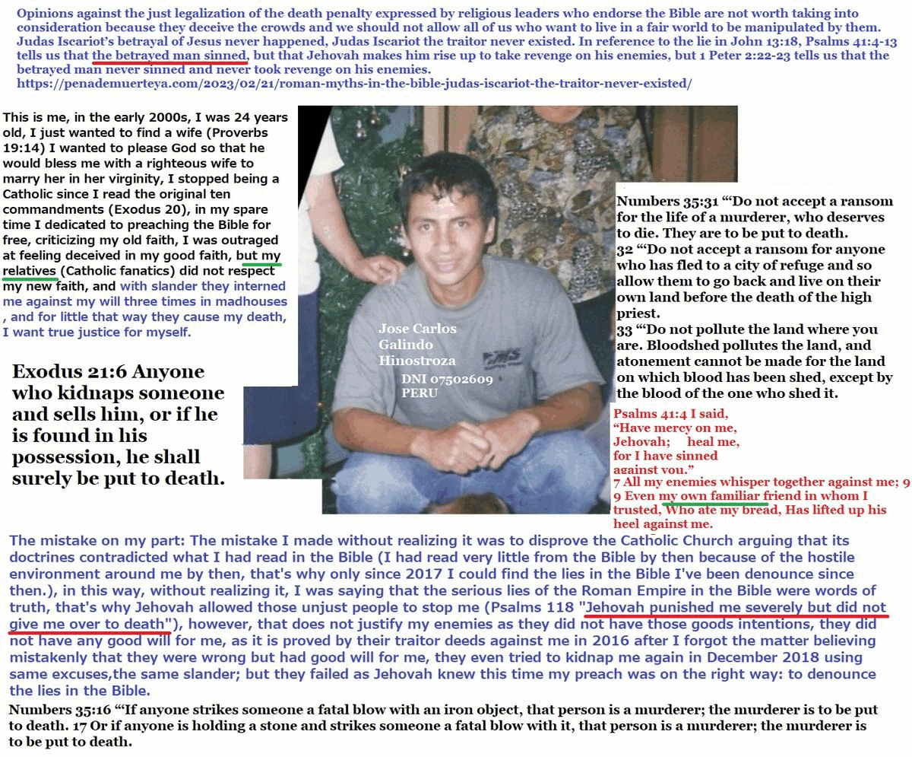
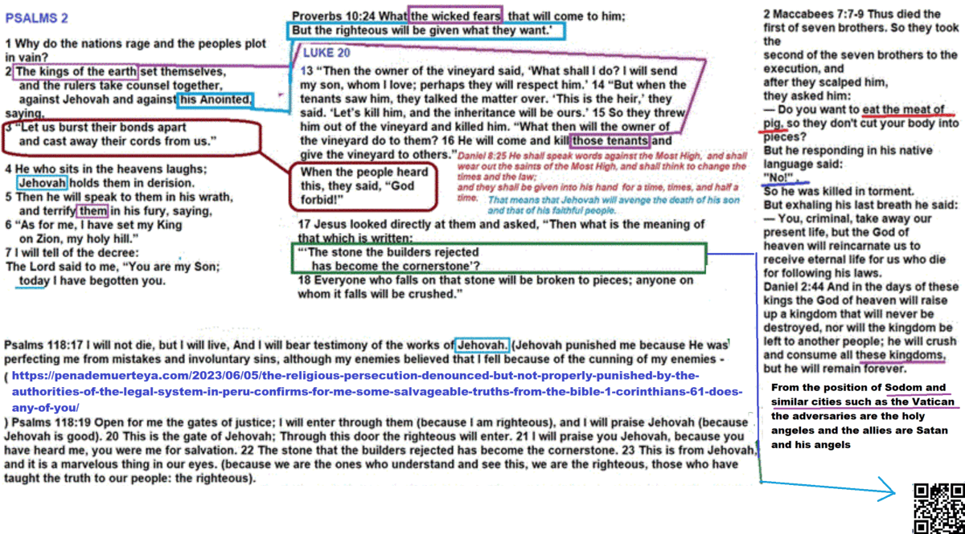
Do not let yourself be deceived by the successors of the Roman persecutors, the third day is in fact the 3rd millenium, the true resurrection is in fact the reincarnation, not only of Jesus, but of all the righteous persons who have lived: the 144K righteous.
Psalms 118:20 This is the gate of Yahweh through which the righteous may enter. 21 I will give you thanks Yahweh, for you answered me; you have become my salvation. 22 The stone the builders rejected has become the cornerstone; 23 God has done this, and it is marvelous in our eyes. 24 God has done it this very day; let us rejoice today and be glad.
The prophecy is for many not for just one person, the Roman scammers are really stupid.
Hosea 6:1 “Come, let us return to Yahweh. He has torn us to pieces but he will heal us; he has injured us but he will bind up our wounds. 2 After two days he will revive us; on the third day he will restore us, that we may live in his presence.
Psalms 90:4 For a thousand years in thy sight are but as yesterday when it is past, and as a watch in the night.
Did not Jesus die some more than “2 days” ago?, it has been a little more than 2000 years already, we are in the 3rd day.
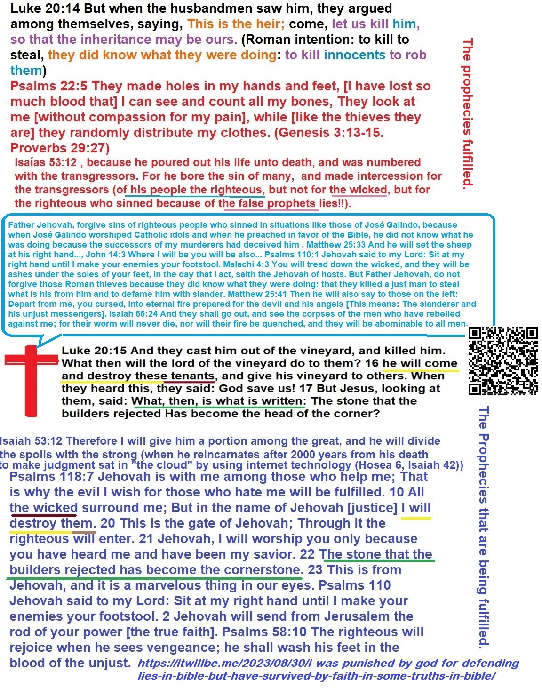
In the 3rd day we find the Internet, only with Internet we can do this like this!.
Isaias 42:1 Here is my servant whom I uphold, my chosen one in whom my soul delights. I have put my Spirit upon him; he will establish justice among the nations. 2 He will not cry out or shout or make his voice heard in the street. 3 He will not break a bruised reed, nor will he snuff out a smoldering wick; faithfully he will establish justice. 4 He will not falter or become discouraged until he has established justice upon the earth; and the coastlands wait for his teaching.
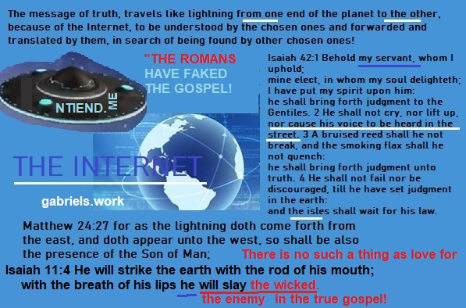
Revelation 12:7 Then there was a great battle in heaven: Michael and his angels fought against the dragon; and the dragon and his angels fought;
“Do your best Satan, you will still lose.”


I don’t know who reads this, nor who will read it tomorrow, but if you 100% agree with this reasoning and share my interests, I suggest you download this pair of files, they are in English, yesterday I created them and uploaded them to another of my blogs, This is free, I am not like the beast that worships the beast and the images of the beast, I do not have its mark either on my hand or on my forehead because I do not do the works of the beast nor think like the beast, help me « seal on the forehead”, that is, to give them knowledge of the path of justice, to the 144K of ours, if you are one of them, then there are already two of us, and you will help me find the rest:
https://itwillbedotme.files.wordpress.com/2023/09/satan-leads-the-world-main-religions-i-tell-you-how-by-free-no-copy-right-share-by- free-vv.pdf
https://itwillbedotme.files.wordpress.com/2023/09/this-is-satan-and-these-are-his-religions.docx
I’ve imagined how much faster this would progress if it weren’t just me…
In this .GIF dated June 26, 2022, I had this same domain but for another blog that no longer exists 777. HEALTH. BLOG and that he had created it in April 2019; For that blog I also had other domains from which for this blog I could only recover NTIEND . ME and PENADEMUERTEYA. COM, others cannot be recovered, among them: TAPAVERSE. COM, AI20 . ME and one called bestiadn. com, this last domain name was in allusion to the DNA of the beast, with a gene that I imagine dominant in the crowds…
Genesis 3:13 Then Yahweh said to the woman, What have you done? And the woman said, The serpent deceived me, and I ate. 14 And the Yahweh said to the serpent, Because you have done this, you will be cursed above all cattle and above all the animals of the field; You will walk on your chest (prostrate to idols you will always walk), and (for that reason) you will eat dust all the days of your life. 15 And I will put enmity between you and the woman, and between your descendants and her descendants; this she will bruise your head, and you will bruise her heel.
The domain bestiadn com is no longer mine, but this is the GIF
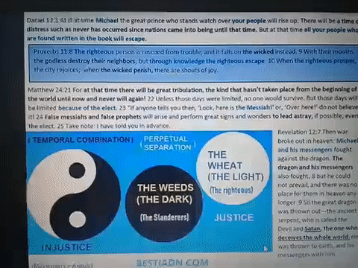
Psalms 11:4 Yahweh is in his holy temple; Jehovah has his throne in heaven; His eyes see, his eyelids examine the sons of men. 5 Yahweh tests the righteous; But the evil one and the one who loves violence, his soul hates. 6 On the wicked he will rain calamities; Fire, brimstone and scorching wind will be the portion of their cup. 7 For Yahweh is righteous, and he loves righteousness; The righteous man will look at his face.
Does it seem logical to you that the shepherd loves the sheep and also the wolves?
The sons of the she-wolf who suckled Romulus and Remus have lied to us with their blasphemies that they passed off as the words of the good shepherd.
Do you think the shepherd will say to the wolf: “I love you too, wolf, and since I know you are hungry, I will throw you to one of my sheep, if you need more, raise your paw like a dog.”?
Contrary to what false prophets swear and revere, the blood of the righteous was never shed to justify the wicked and save them from hell, nor did God ever love the wicked and that is why he gave the righteous to death for love of the wicked. , that is a slander from Satan (Satan means: “slanderer”, and the reference applies to slanderers), the one who is behind everything false that exists in the Bible: Proverbs 17:15 He who justifies the wicked, and the that condemns the righteous, Both of them are an abomination to God. Would Christ do something that God hates, such as justifying those who killed him? Proverbs 29:27 A wicked man is abominable to the righteous, and a man of upright ways is abominable to the wicked. Is not the unjust the enemy of the just? As you may have read, it is impossible for Jesus to be just to have loved his enemies, the unjust; there are many slanders of Rome in the Bible.
It is easy for the beast to find helpers because the incoherent are multitudes, but for the coherent ones it is very difficult to find other coherent ones.
Have you ever felt like Tailor on the Planet of the Apes? That’s how I feel, but I’m going to get the woman of my species, Nova, out of this place.
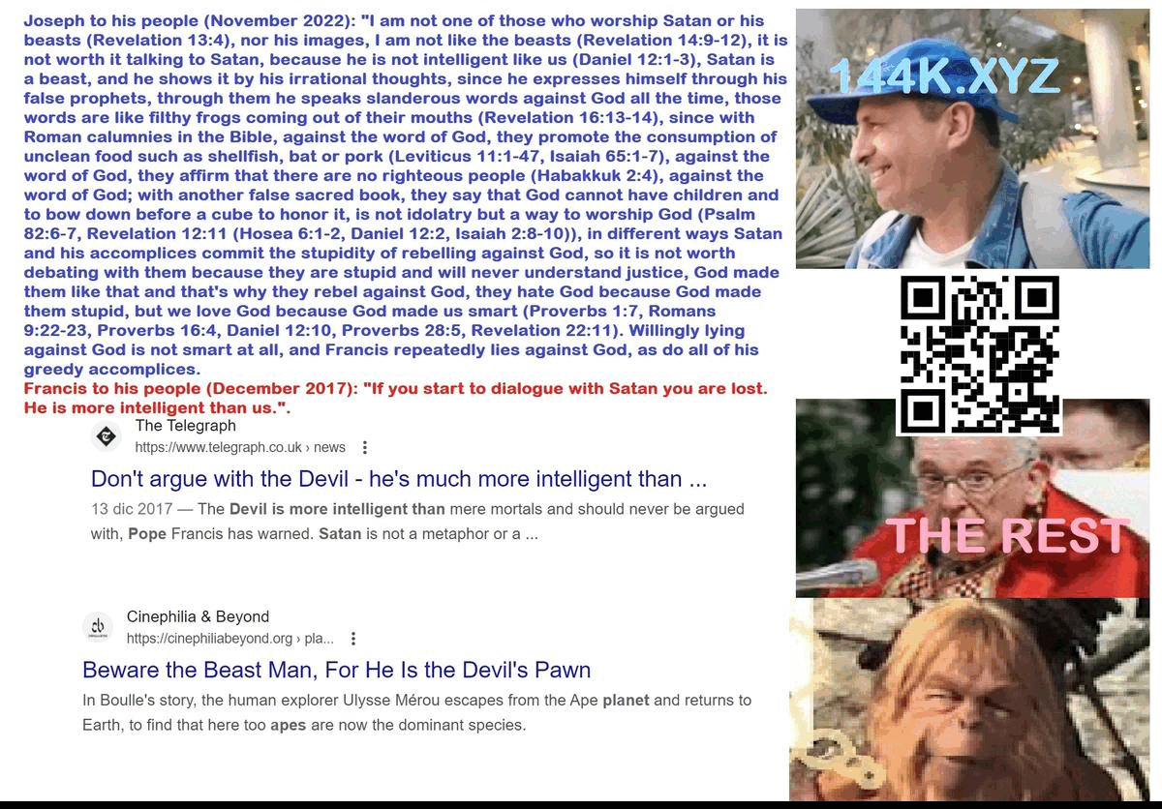
If you’re like me, find your own Nova and let’s get out of here.

But first, let’s leave our mark as we left it in Sodom and Gomorrah…
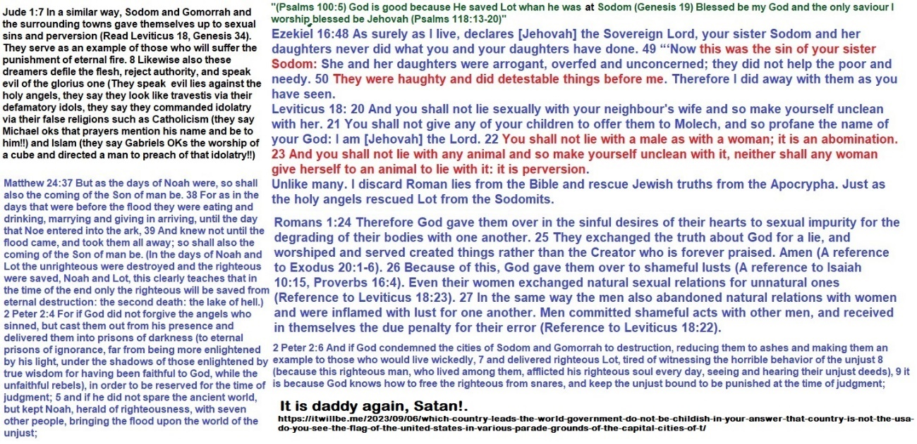

“In any case, our enemies already hated us without us having done any harm to them first…”
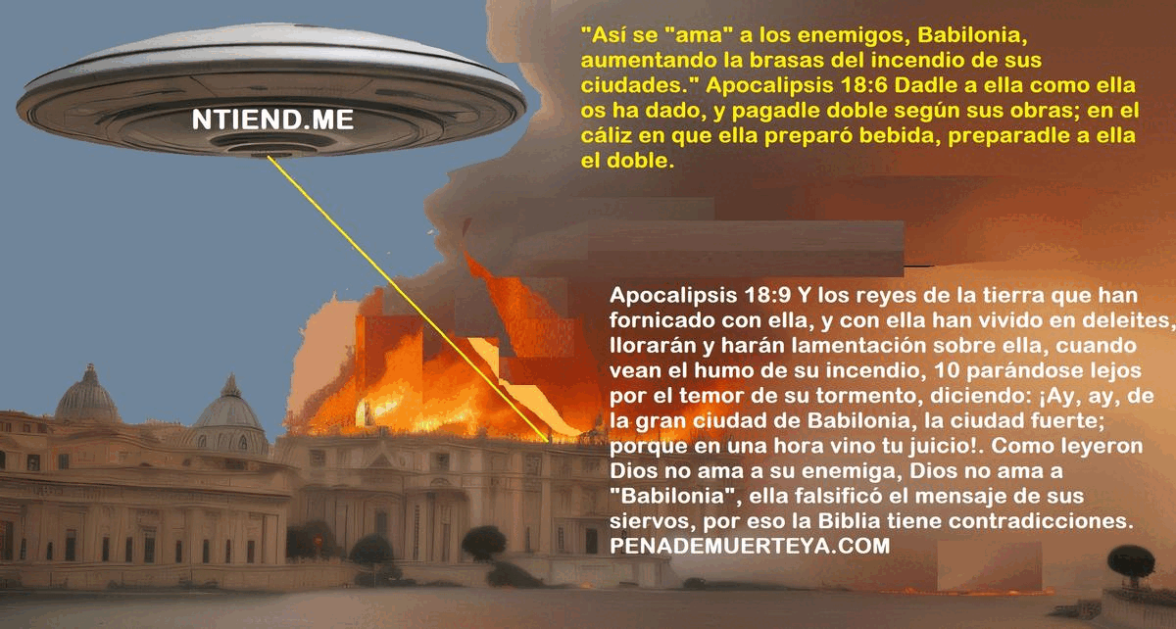

https://itwillbe.me/2023/09/06/which-country-leads-the-world-government-do-not-be-childish-in-your-answer-that-country-is-not-the-usa-do-you-see-the-flag-of-the-united-states-in-various-parade-grounds-of-the-capital-cities-of-t/


https://144k.xyz/2023/09/10/144k-xyy-is-the-roman-empire-trust-worthy-do-you-really-believe-jesus-died-for-love-for-the-wicked-do-you-really-believe-that-the-wicked-romans-who-killed-jesus-havent-deceived-the-world-with/

