The gospel different from the Bible - Different from the gospel skewed to the taste of the Roman persecutors.
The Gospel of Gabriel - The gospel different from that preached by the Roman impostors.
https://gabriels.work/wp-content/uploads/2023/08/gabriel-el-heroe-de-la-princesa.gif

"With a few clicks, I turn the slanderous dinosaur to dust, because the truth is older than the Bible, older than the ancient serpent, older than the dragon."
https://gabriels.work/wp-content/uploads/2023/12/this-is-gabriel-he-is-a-straight-man-with-short-hair-in-his-youth-although-now-is-semi-bald-he-resembles-thus-the-enemy-of-the-devil.gif
https://gabriels.work/wp-content/uploads/2023/12/gabriel-s-work-logo.gif

“Judas Iscariot, the tale”: The Roman betrayers are the traitors against mankind faith! The Romans are the Judas Iscariot, who never has existed, read this report “Judas Iscariot the Tale”
Who defeated Satan according to Revelation 12:11? It seems contradictory, but they are not the Christians.

The Romans persecuted a religion, the religion of Jesus. What they stopped persecuting after several centuries and began to defend was not Jesus’ religion, it was their religion: Christianity, in which there are some elements of Jesus’ religion, but most of which are not his doctrine.

Judas Iscariot the traitor did not exist, that is a Roman lie like many other Roman lies in the Bible.

Psalms 41: 4-13 Tells us that the betrayed man did sin, but that Jehovah makes him rise to take revenge on his enemies.
But 1 Peter 2:22-23 tells us that the betrayed man never sinned that he never took revenge on his enemies.
Read this, they have tried to associate with the life of Jesus, a prophecy for the time of the end that was not fulfilled in him, when he came to die on the cross:
John 13:18 I am not speaking of all of you; I know who I have chosen. But the Scripture must be fulfilled:
“He who eats bread with me lifted up his foot against me.”
Look at this other inconsistent statement:
John 6:64 But there are some of you who do not believe
Because Jesus knew from the beginning who those who did not believe were, and who would betray him…
1 Peter 2:22 Christ never sinned…

VS.

Psalms 41:4 I said, Jehovah, have mercy on me; Heal me, for I have sinned against you.
Psalms 41:7 All those who hate me murmur against me together; They think evil against me, saying of me:
8 A pestilential thing has taken hold of him;
And he who fell to bed will never get up again.
Psalms 41:9 Even the man of my peace, in whom I trusted, who ate my bread, has lifted up his heel against me.
10 But you, Jehovah, have mercy on me, and raise me up and I will have revenge on them.
11 By this I will know that I have pleased you,
May my enemy not prevail against me.
12 As for me, you have sustained me in my integrity,
And you have made me stand before you forever.
13 Blessed be Jehovah, the God of Israel,
Forever and ever.
Amen and amen.
Can someone explain to me how it is possible for someone to trust someone who they know from the beginning is a traitor?
The prophecy that the Romans, in their invented history, refer to in Psalms 41 says that the betrayed trusted the traitor, but according to this story invented by the Romans about the betrayal of one Judas Iscariot against Jesus, Jesus the betrayed , he already knew from the beginning that Judas Iscariot was the traitor. That does not fit with the prophecy, because Psalms 41:7-13 is a prophecy for the time of his return, because the betrayed man manages to get up and thanks Jehovah for that, he gets up like Michael gets up in the time of the end, It is a prophecy for the end time, as are Psalms 112, Psalms 91, Daniel 12, Psalms 110, Psalms 118, Isaiah 11, Isaiah 42, etc.
The little horn, the Vatican, what remains of the Roman Empire, repeats the blasphemies of the Roman Empire against Jehovah in its attempt to change the laws and prophecies by adulterating the messages that the saints of the Most High said, but when the saints reincarnate, they They deny their enemies. They are reincarnated after 2000 years of the blood of the holy covenant on the cross (Hosea 6:1-3), in the age of the Internet, a means by which they make judgment (Isaiah 42:1-18, Isaiah 65) , since they have the power to judge because they were faithful to Jehovah and did not worship the pagans, nor to their idols, nor did they eat swine’s flesh (1 Kings 19:18, Ezekiel 23:45, Malachi 3:18, 2 Maccabees 7:7-9). If you find contradictions in the old testament of the Bible, blame it on the Romans too.
The prayer of the righteous, for forgiveness of his own sins committed due to his past ignorance.
Psalms 41: I said, “Have mercy on me, Jehovah; heal me, for I have sinned against you.”
(In my youth I prayed to catholic images, I used to say that the Bible has only the truth,
I ate pork meat, but I did those sins while I was ignorant of the truth).
Little by little I learned, when I learned what idolatry was and stopped praying to images, my relatives treated me with treason for my warning them of the sin behind praying to catholic images, they slandered me and kidnapped me because of it.
Psalms 41:9 Even my close friend, someone I trusted, one who shared my bread,
has turned against me.
Psalms 109:1 Jehovah, whom I praise,
do not remain silent, 2 for people who are wicked and deceitful
have opened their mouths against me;
they have spoken against me with lying tongues.
3 With words of hatred they surround me; they attack me without cause.
4 In return for my friendship they slander me, 5 They repay me evil for good,
and hatred for my friendship.
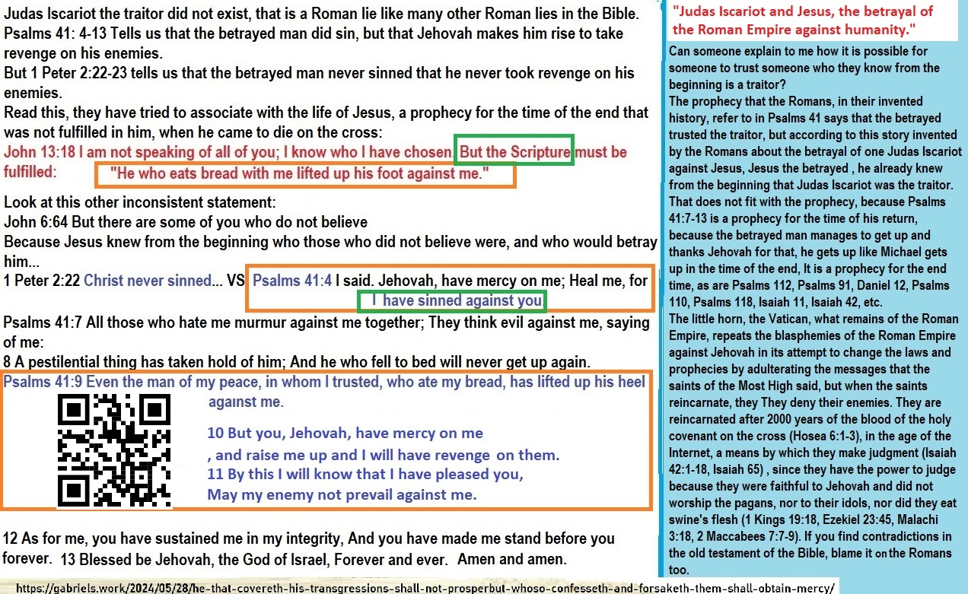
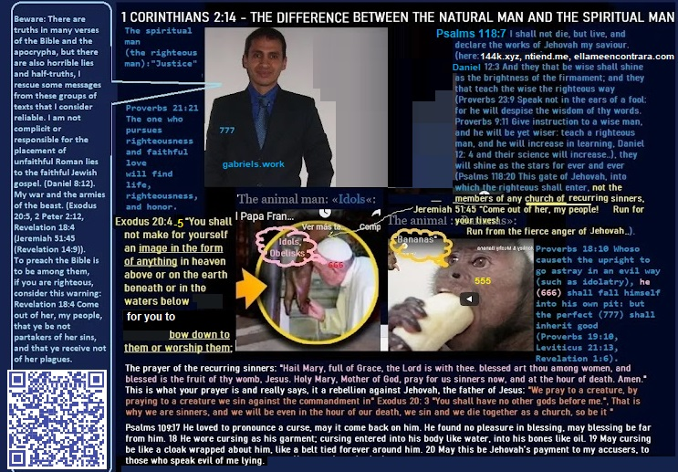
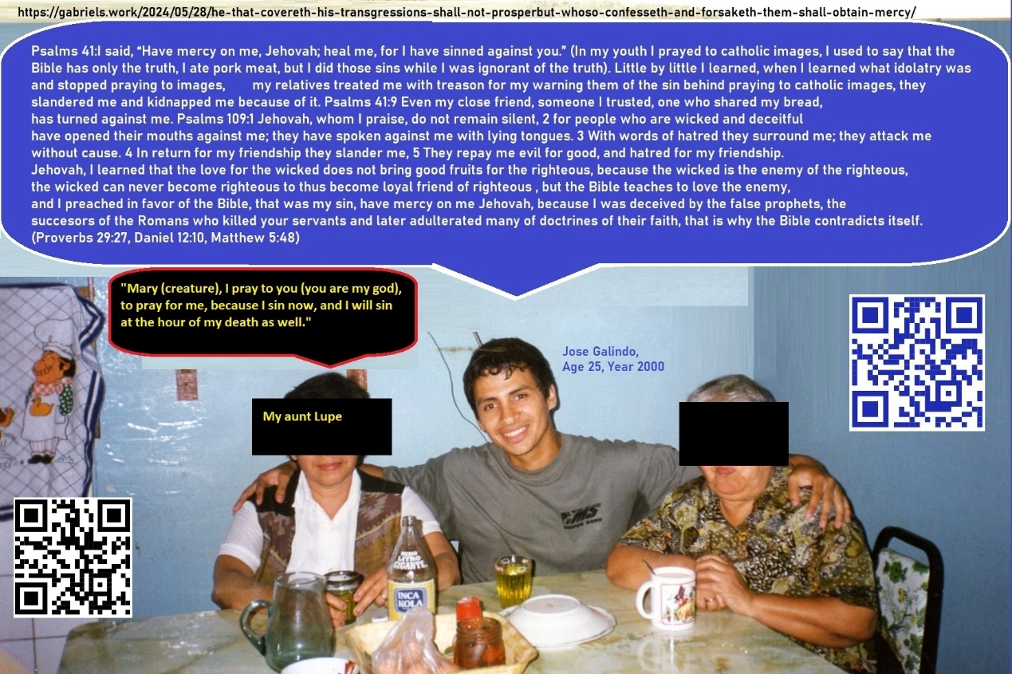

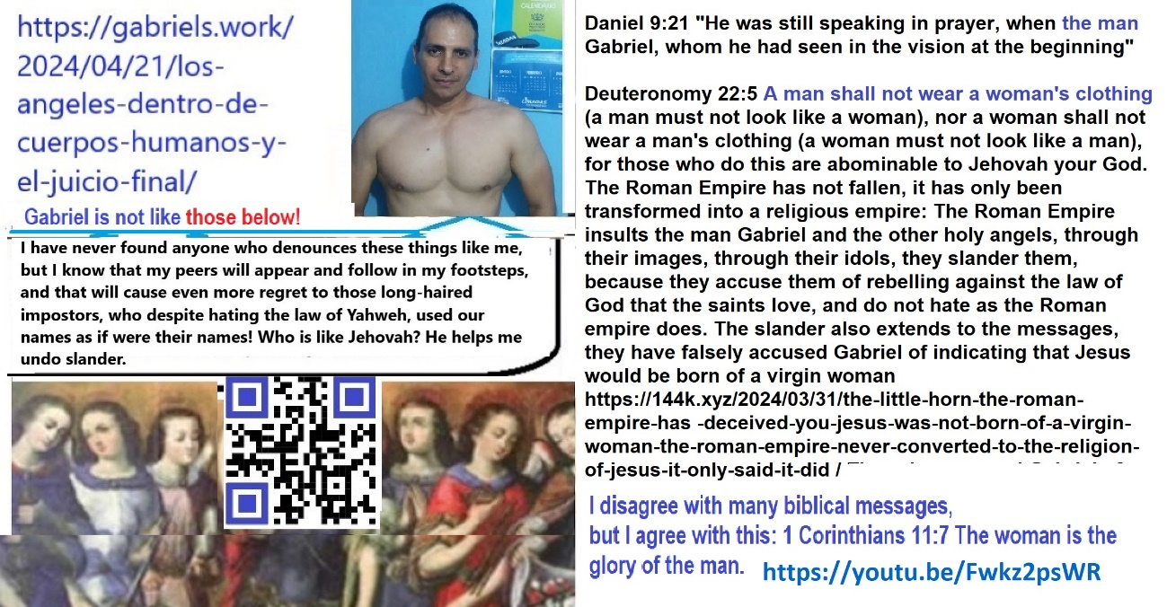

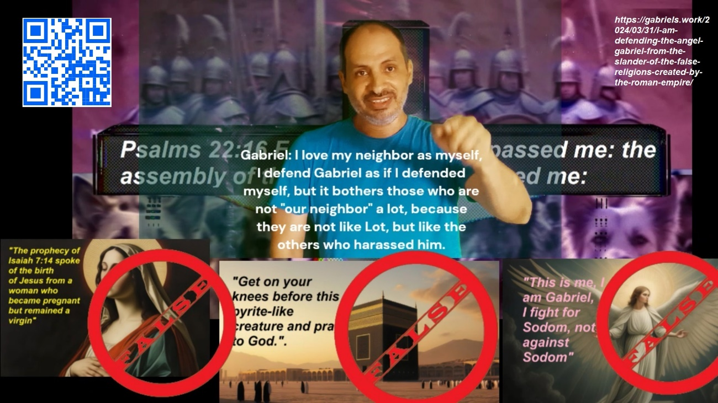
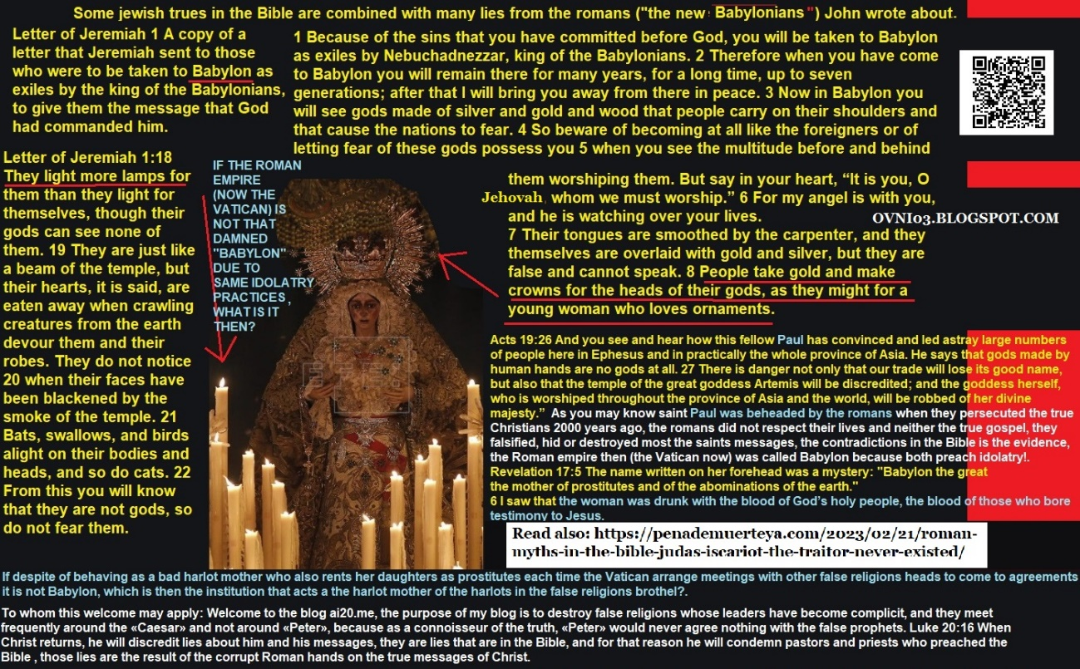

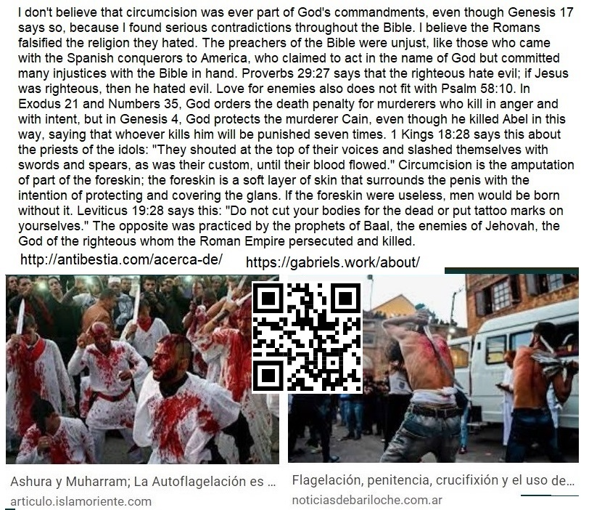
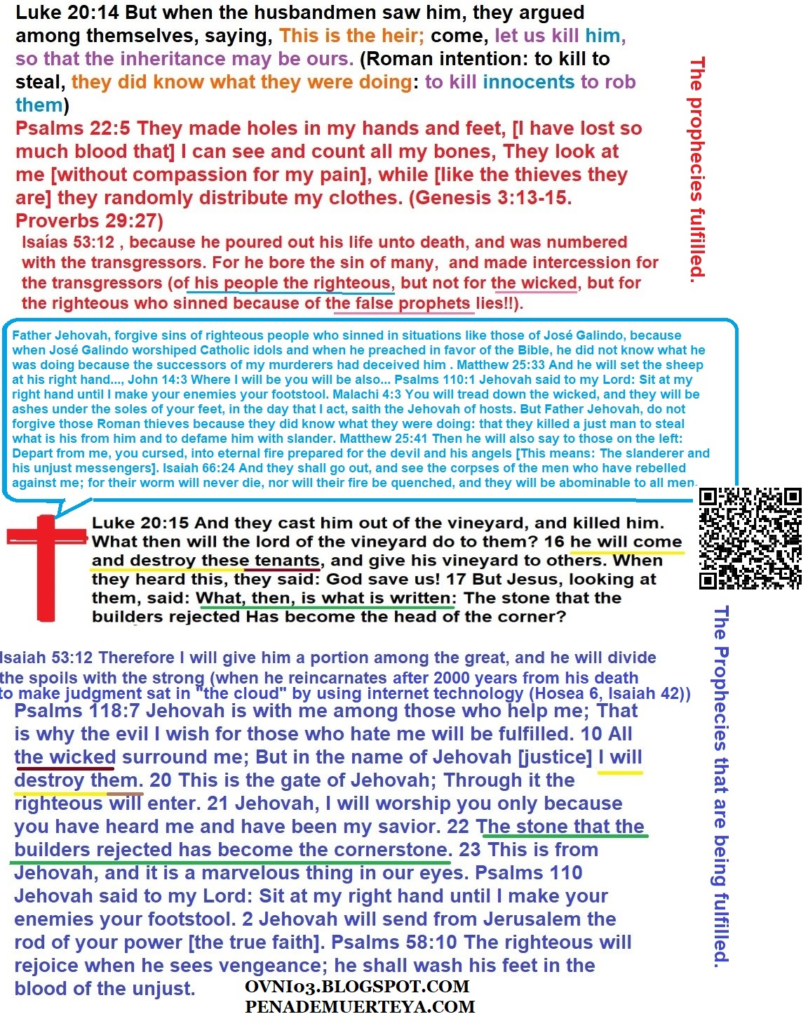

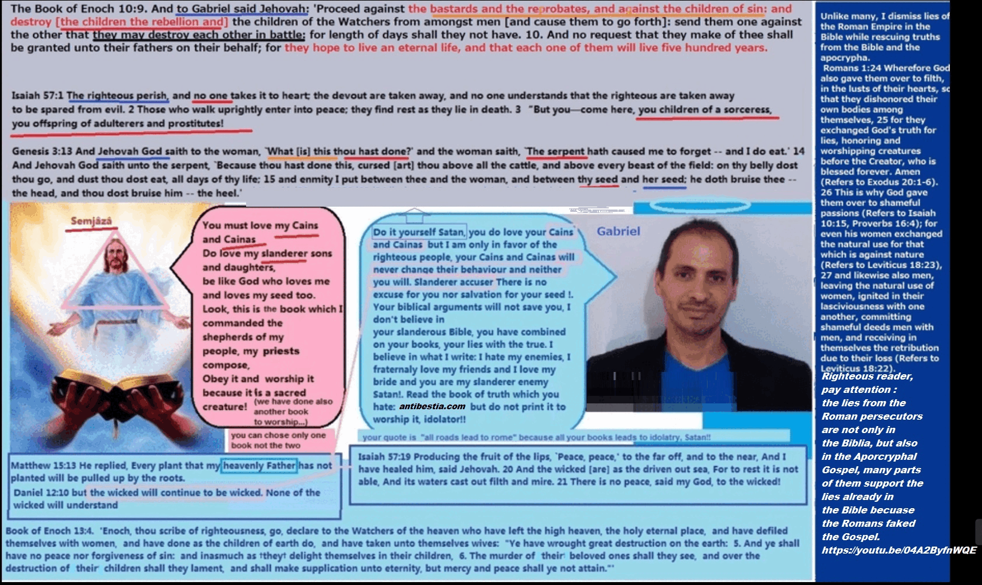
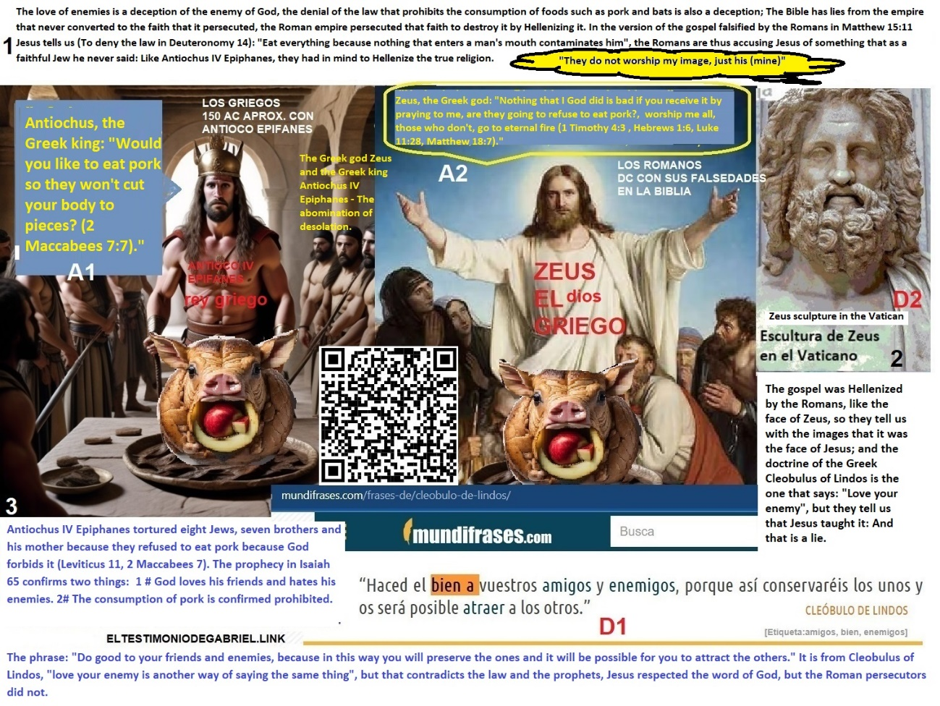
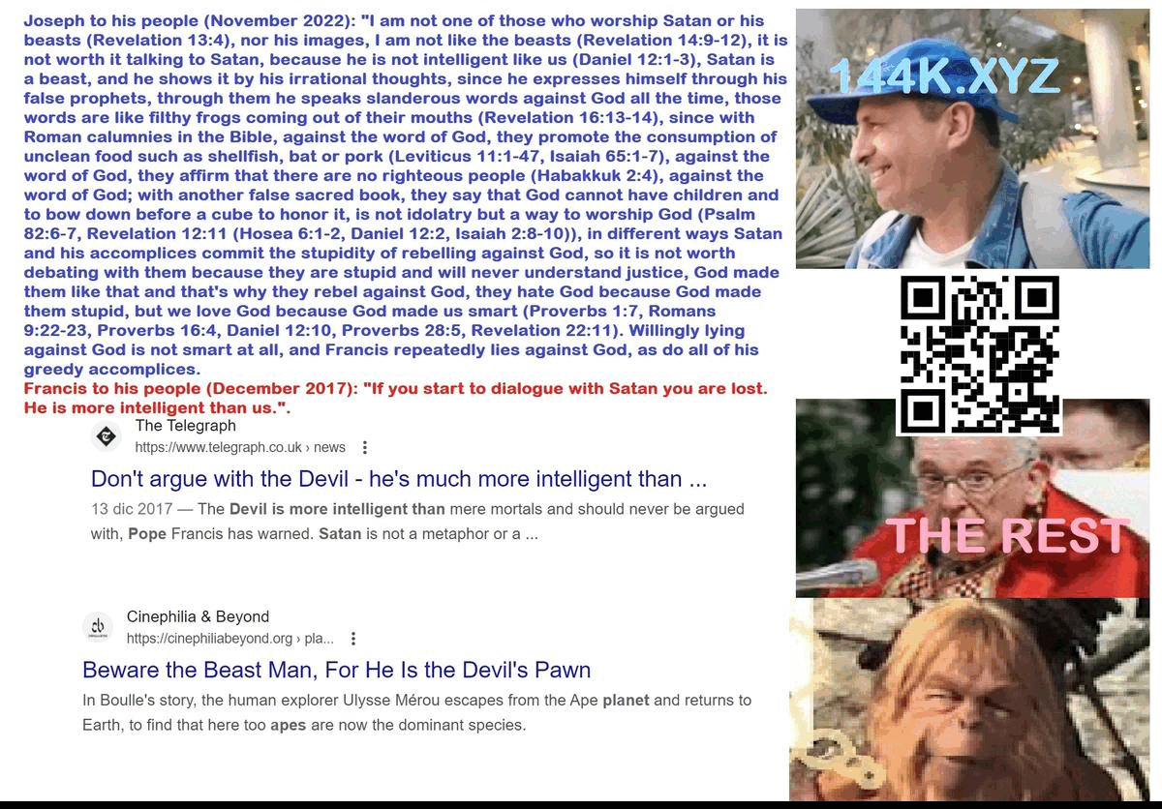
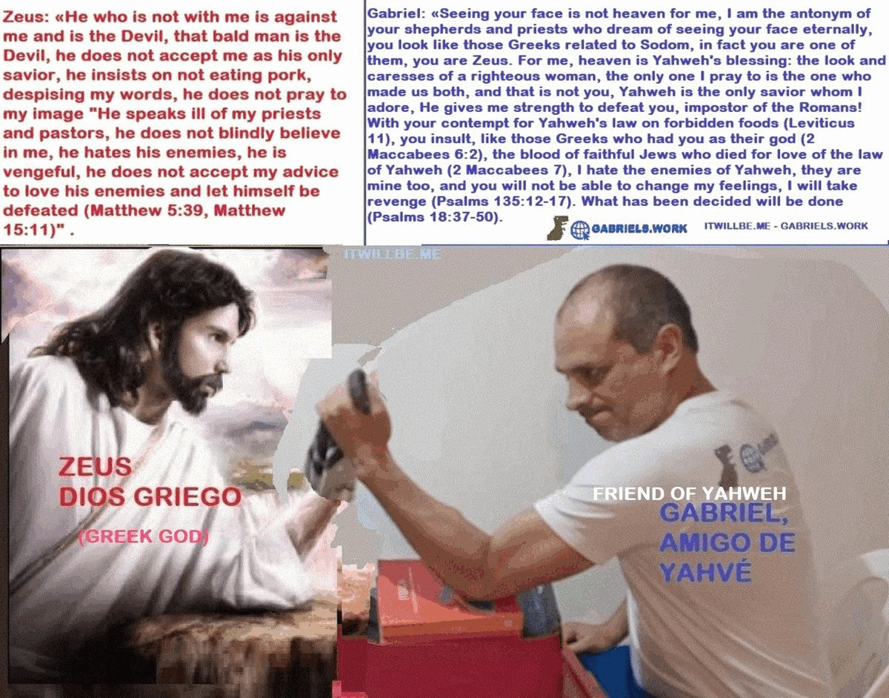

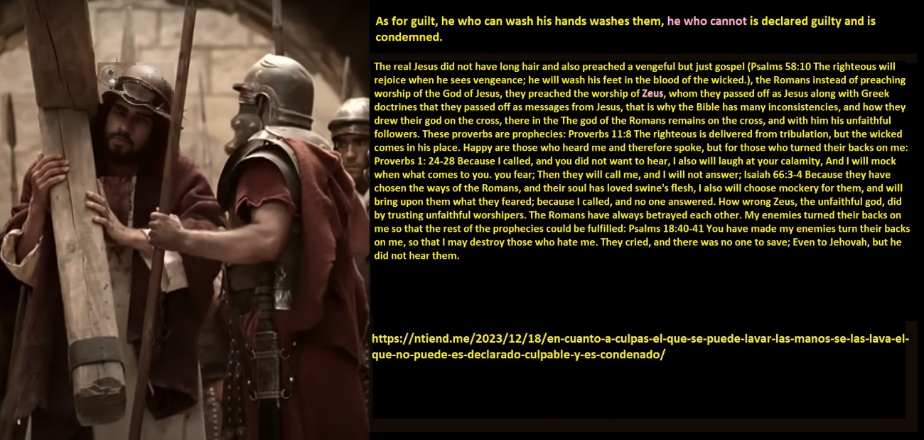
https://youtu.be/ryPJ5mcDQsE | If Jesus had short hair, then, Who's at the cross?
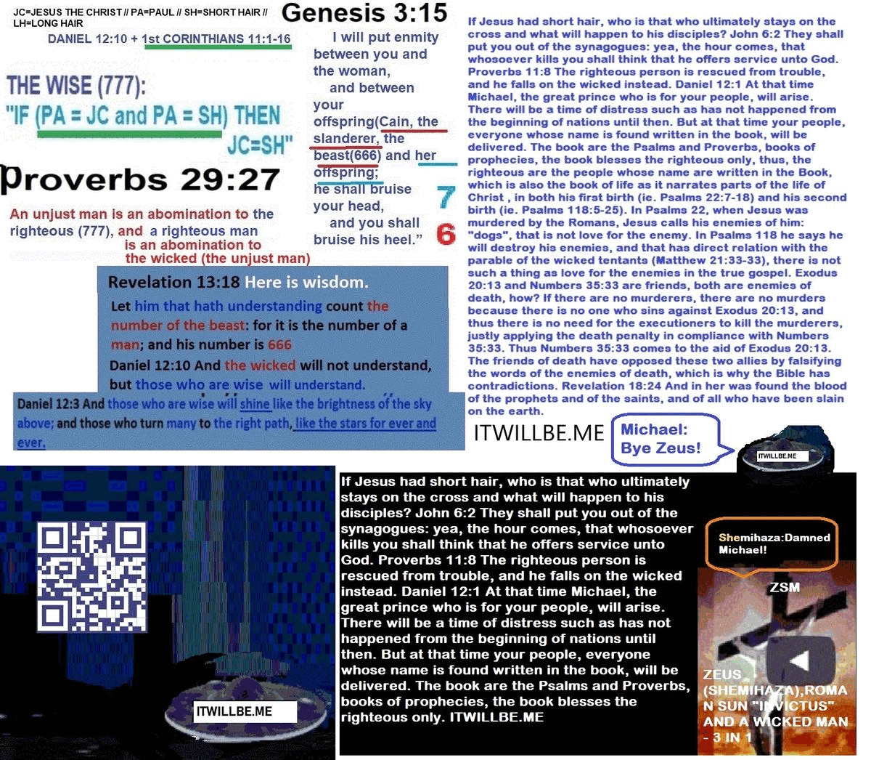
Revelation 12:10 Then I heard a loud voice in heaven saying, Now has come salvation, and power, and the kingdom of our God, and the authority of Christ from him; for he has been cast out as the accuser of our brothers, who accused them before our God day and night. 11 And they have overcome him by the blood of the Lamb and by the word of their testimony, and they despised their lives unto death. 12 Therefore rejoice, heavens, and you who dwell in them. Woe to the inhabitants of the land and the sea! for the devil has come down to you in great wrath, knowing that he has but a short time.
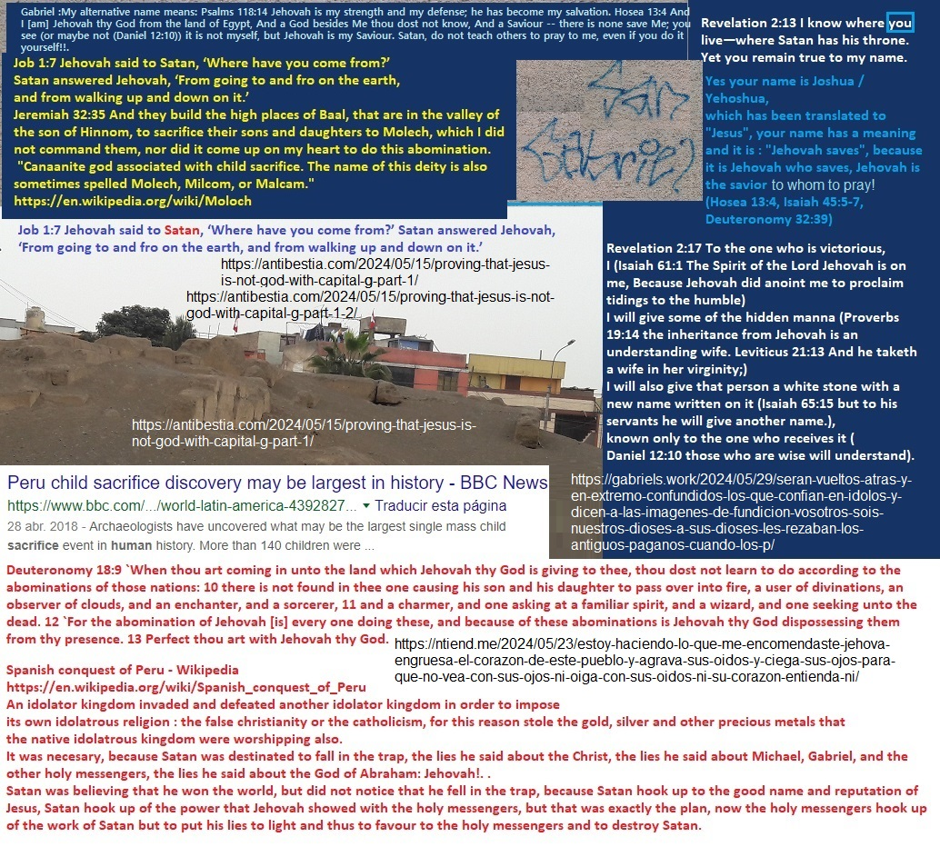
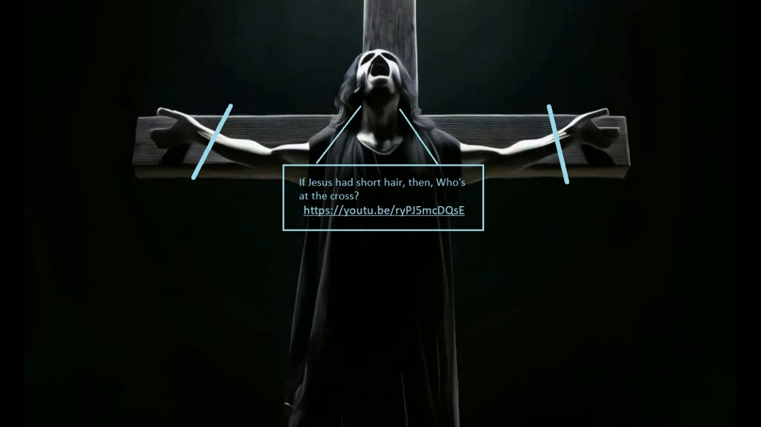
«They have defeated Zeus, by the blood of the holy covenant, because they despised their lives until death» –

This comment I made on a video with the title: “Man dressed as Jesus”, will give clues to understand:
Clarify, man dressed as Zeus, that pagan god of those who ate pork, by whom the Romans Hellenized the gospel, that is why the Bible in Matthew 15: 11 contradicts Isaiah 66: 17, among other contradictions… They, the who refused to eat pork (2 Maccabees 6:2, 2 Maccabees 7:7-10, Leviticus 11), are those who despised their lives to the point of death in their first life. Does it seem logical to you that they chose to die in instead of eating pork, so that in their second life they eat pork because of what the Bible says in 1 Timothy 4: 1-6 and Matthew 15: 11?… they are the ones who have been reincarnated in the third millennium (Hosea 6:2, Daniel 12:2-3), and live in heaven (at the right hand of God, Psalms 118:7-25, Matthew 21:38-42). Revelation 12:10 Then I heard a loud voice in heaven saying, Now has come salvation, and power, and the kingdom of our God, and the authority of Christ from him; for he has been cast out as the accuser of our brothers, who accused them before our God day and night. 11 And they have overcome him by the blood of the Lamb and by the word of their testimony, and they despised their lives unto death. 12 Therefore rejoice, heavens, and you who dwell in them. Woe to the inhabitants of the land and the sea! for the devil has come down to you in great wrath, knowing that he has but a short time.
The blood of the Lamb was never for the forgiveness of wicked people because:
Proverbs 17:15 He that justifies the wicked, and he that condemns the just, even they both are abomination to Jehovah. As Psalms 41 and Psalms 118:17-20 shows, the blood of the Lamb was for the forgiveness of sins of the righteous, who at their second life are not educated in the true religion and do sins because of their ignorance.
Daniel 7:21 And I saw this horn making war against the saints, and prevailing against them.
Revelation 13:7 And he was permitted to make war against the saints and defeat them. It was also given authority over every tribe, people, language and nation.
Daniel 7:22 until the Ancient of days came, and judgment was given to the saints of the Most High; and the time came, and the saints received the kingdom. Revelation 7:3 “Do not harm the land or the sea or the trees until we put a seal on the foreheads of the servants of our God.” 4 Then I heard the number of those who were sealed: 144,000 from all the tribes of Israel. The reincarnated righteous people of Daniel the jew prophet are those 144,000, because only the righteous people can serve a righteous God such as Jehovah.
Malachi 3:18 Then you will return and discern between the righteous and the wicked, between him that serve God and him that does not serve him.
Ancient of days, is an allusion to the wisdom of light, of truth.
Solomon prophesied it in these proverbs:
Proverbs 11:9 A hypocrite destroys his neighbor with his mouth, but the righteous are saved by knowledge. 10 With the good of the righteous the city rejoices, and when the wicked perish, there are festivals. The system of false religions led by hypocrites will be completely destroyed. Daniel 7:11 Then I looked because of the sound of the great words that the horn spoke; He watched until the beast was killed, and his body was torn apart and handed over to be burned in the fire.
Daniel 12:1 “Daniel, you must know this, at that time shall arise Michael, the great prince who has charge of your people. And there shall be a time of trouble, such as never has been since there was a nation till that time. But at that time your people shall be delivered, everyone whose name shall be found written in the book.
Proverbs 11:8 Righteous people escape from trouble. The trouble happens to wicked people instead.
2 Maccabees 6:18 Eleazar, one of the main teachers of the law, a man of advanced age and noble appearance, was forced to eat pork by opening his mouth. 19 But he, preferring an honorable death to a life without honor, voluntarily went to the place of torture 20 after having spit out the meat. He behaved as those who firmly reject what they are not allowed to eat, even for the love of life, should behave.
Deuteronomy 14:3 You shall eat nothing abominable. ..8 nor a pig, because it has a cloven hoof, but it does not chew the cud; it will be unclean to you. You shall not eat their flesh, nor touch their dead bodies.
2 Maccabees 7:9 But he, breathing his last, said, “You criminal, you take away our present life.” But the King of the world will resurrect us who died by his laws to eternal life. (They are now «in heaven», he reads on, if you are one of them, you will understand).
All conditions are given!
THE TIME HAS COME!!
#1 – Two “days” have passed since the death of Jesus (2 millennia have passed):
Psalms 22:15-18, Hosea 6:1-2. Psalms 90:4.
#2 – The technology to judge in distant places without raising your voice in streets or squares already exists,
the internet exists (Isaiah 42:1-18,
Psalms 110:1-7, Isaiah 11:1-4)
#3 – There is at least one man who does what no one has ever done: defend the justice of the eye for an eye law by denouncing
Roman lies in the Bible that oppose that law (Daniel 25:8, Daniel 7:25-27, Deuteronomy 19:18-21).
Then it is the time of the fulfillment of many pending prophecies, among which are those contained in:
Psalms 91:7-16, Isaiah 6:10-13, Psalms 58:10-11, Psalms 118:5-25, Daniel 12:1-13, Micah 7:9-13, Psalms 41:4-13).
Isaiah 42:12 Give glory to Jehovah and declare his praises the coasts. Revelation 14:7 Fear God and give glory to him, because the hour of his judgment has come; and worship him who made the sky and the earth, the sea and the sources of water.
Isaiah 42:4 He will not fail nor be discouraged, till he has established justice in the earth; And the coastlands shall wait for his law.”
Exodus 21:16 «Anyone who kidnaps someone is to be put to death, whether the victim has been sold or is still in the kidnapper’s possession.
Circumcision in the Bible. I do not believe that circumcision was ever part of God’s commandments, even though Genesis 17 says so, because I found serious contradictions throughout the Bible, I believe that the Romans falsified the religion they hated. The preachers of the Bible were unjust, like those who came with the Spanish conquistadors to America, who claimed to act in the name of God, but committed many injustices with the Bible in their hands. Proverbs 29:27 says that the righteous hate the evil, if Jesus was righteous then he hated the evil, love of enemies does not fit with Psalms 58:10 either. In Exodus 21 and Numbers 35 God commands the death penalty for murderers who kill with anger and intention, but in Genesis 4 God protects the murderer Cain, even though he killed Abel in this way, saying that whoever kills him will be punished 7 times , 1 Kings 18:28 tells this about the priests of idols: “They cried with loud voices, and cut themselves with knives until the blood flowed on them.” Circumcision is amputating part of the foreskin, the foreskin is a layer of skin soft that surrounds the penis with the intention of protecting and covering the glans, if the foreskin were useless, men would be born without a foreskin. Leviticus 19:28 says this: “You shall not make cuts in your body, nor print marks on your skin.” The opposite was practiced by the prophets of Baal, the enemies of Jehovah, the God of the righteous whom the Roman Empire persecuted and killed.
https://ntiend.me/2023/04/06/the-deception-of-the-roman-empire-in-the-bible-vs-the-message-of-the-persecuted-in-the-time-of-christ-el-engano-del-imperio-romano-en-la-biblia-vs-el-mensaje-de-los-perseguidos-en-los-tiempos-de-cri/ | The deception of the Roman empire in the Bible vs. the message of the persecuted in the time of Christ.

https://ntiend.me
https://gabriels.work
https://ellameencontrara.com
https://144k.xyz
https://daniel-chapter-xii.tripod.com
https://antibestia.com
https://labibliasecontradice.blogspot.com/



